Yellow Wood Sorrel
Oxalis stricta L. (O. europaea Jordan; O. Fontana Bunge)

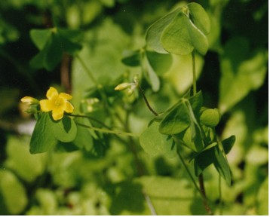

Yellow Wood Sorrel Leaves and Flowers

There are about thirty species of Wood Sorrels in the United States. Yellow Wood Sorrel is found in gardens, lawns, woods, fields, and on roadsides. The leaves are palmately divided and have three heart-shaped leaflets that fold in the center and open in the morning and close in the evening.
The Yellow Wood Sorrel plant has quarter to half-inch wide yellow flowers with five petals and ten stamens. The flowers form in clusters on long, thin stalks.

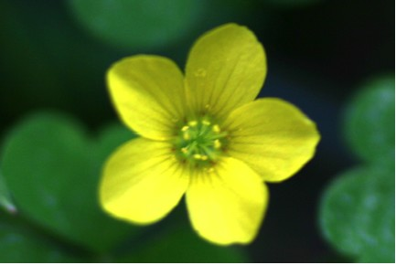

Yellow Wood Sorrel Flower

The seeds form in a pointed capsule.
The pale green leaves, stems, and flowers have a sour taste and can be added to salads. Seedpods can also be used in spring. The leaves can be used to make a drink like lemonade. Recipes for using the plant in soups, hot dishes, and desserts can also be found in wild food cookbooks. Leaves contain oxalic acid so they need to be eaten in moderation just as one would do with rhubarb stalks that contain the same substance.

