Yellow Wood Sorrel
Oxalis stricta L. (O. europaea Jordan; O. Fontana Bunge)

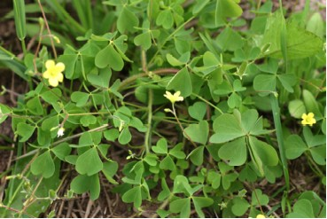

Yellow Wood Sorrel Plants

“For God so loved the world that he gave his only Son, so that everyone who believes in him may not perish but may have eternal life. “Indeed, God did not send the Son into the world to condemn the world, but in order that the world might be saved through him. John 3:16-17 (NRSV)

The Heart – Symbol of Love
The pale green leaflets of the Yellow Wood Sorrel are heart-shaped. The leaflets open in the morning and close in the evening. They fold down the middle and remind one of the hearts children cut by folding paper, drawing half of a heart, cutting it out and then unfolding it to reveal the shape of a heart.
The heart shape is often used as a symbol of love. The unfolding and folding of the Yellow Wood Sorrel leaflet can remind us that God loved the world so much that he sent his only Son to die for us. The meaning of the message, “God loves us,” can unfold for us every morning as the sun rises and we are given another day of life. When the sun sets in the evening we can sleep in peace because we are enfolded in God’s love and care.

Dear Heavenly Father,
Thank you for enfolding us in your love and care. Help us to love those around us. In Jesus’ name, Amen.

Things to Think About and Do
• Read other Bible verses about God’s love for us. (Psalm 118:1; 1 Corinthians 2:9; Galatians 2:20; Romans 5:8; 1 John 4:10-16; 2 Corinthians 13:13; John 15:12)
• Find a Yellow Wood Sorrel plant. Watch it throughout a day. Note the opening and closing of the leaflets.
• Draw, paint, photograph or write about a Yellow Wood Sorrel plant.

