Starflower Trientalis borealis

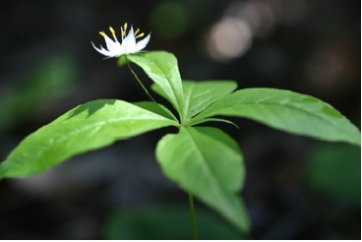

Starflower Blossom and Leaves

The Starflower is a member of the Primrose Family. It grows well in acid soil under our Black Hill Spruce trees. It can also thrive under deciduous trees in other types of soil as far north as Zone 2. The plants can grow up to nine inches high.
The star-shaped, white flowers form on stems that are set a distance above shiny green leaves. There may be five to ten lance-shaped leaves that form a whorl around the flower. The flowers are about half an inch wide. They can have five to nine petals. They usually have seven leaves, sepals, anthers and petals. The anthers are gold. “The majority of dicot flowers have sets of 5 or 6 petals, sepals, and anthers, while monocots more commonly have 3. There are 4- and 8-petaled flowers, but rarely 2- or 7-parted ones.” (Cullina, W., p. 211). Its thin rhizomes help it spread.
In the middle of summer the leaves drop off and only the stem and seed capsules remain.

