Starflower Trientalis borealis

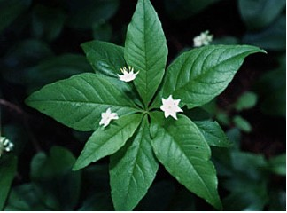

Starflower Blossoms and Leaves

In the time of King Herod, after Jesus was born in Bethlehem of Judea, wise men from the East came to Jerusalem, asking, Where is the child who has been born king of the Jews? For we observed his star at its rising, and have come to pay him homage.” Matthew 2:1-2

“It is I, Jesus, who sent my angel to you with this testimony for the churches. I am the root and descendant of David, the bright morning star.” Revelation 22:16 (NRSV)

Promises Fulfilled
Stars remind us of promises made and promises fulfilled. Long ago people waited for the prophesy of the Messiah to be fulfilled. The wise men from the East studied the stars and followed the star that was a sign that the king of the Jews had been born. They came to worship Jesus. In the book of Revelation Jesus speaks and says he has fulfilled the hopes and dreams of prophets through the ages. He is the “bright morning star” or the Messiah for whom people have waited.
In spring we wait for promised new wildflowers to appear. One of these is the Starflower which has star-shaped, white flowers that form on fragile stems set a distance above a whorl of shiny green leaves. As we look at these delicate Starflowers we are reminded of Jesus, the one who lives forever so that we too can live forever.

Dear Heavenly Father,
Thank you for fulfilling the promise you made to send the Savior. Help us to point others to the “bright morning star” so that they too may be drawn to know and love him. In Jesus’ name, Amen.

Things to Think About and Do
• Read the story of the wise men coming to worship Jesus in the book of Matthew. Think about their hopes and dreams for life as well as our own.
• Find Starflower plants and observe them through the seasons. Keep a record of what you see.

