Wild Sarsaparilla (Aralia nudicaulis)
Wild Sarsaparilla is a member of the Ginseng Family. It has grown as a beautiful green ground cover under our White Pine trees for many years. It grows to be over a foot tall.
The flowers form in ball-shaped clusters at the top of a naked stalk hidden under the umbrella-like leaves. The flowers have tiny petals and five green stamens.

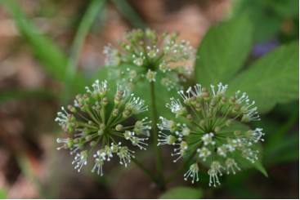

Wild Sarsaparilla Flowers

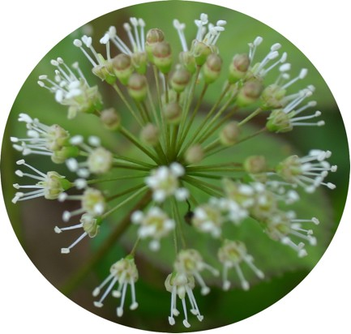

Cluster of Wild Sarsaparilla Flowers

The leaves are pinnately compound and the leaflets are finely toothed. When the leaves first emerge they are tinged with red.

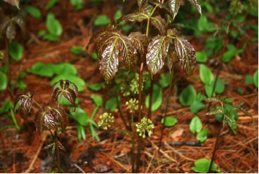

Wild Sarsaparilla Buds on New Plants

Purplish-black berries form in clusters on the plant. Inside are several seeds.
The plant grows from creeping rhizomes that have a pleasant aroma. The rhizomes are long and fleshy and so the plants often appear in groups or colonies.
“Native Americans and pioneers found many uses for the plant. “Early pioneers used wild sarsaparilla to treat fevers, chills, and afflictions of the throat and chest. They also made an aromatic tonic considered to be a gentle stimulant. The aromatic roots have long served as an ingredient in root beer. ….. Indians are said to have existed on sarsaparilla roots while on forced marches.” (Runkel, S., & Bull, A., p. 97).

