Wild Sarsaparilla (Aralia nudicaulis)

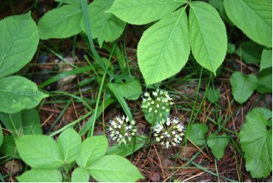

Wild Sarsaparilla Leaves and Flowers

Where Are Our Roots?

As you therefore have received Christ Jesus the Lord, continue to live your lives in him, rooted and built up in him and established in the faith, just as you were taught, abounding in thanksgiving. Colossians 2:6-7 (NRSV)

The way in which a plant is rooted in the ground affects its growth. Wild Sarsaparilla has fleshy, long, creeping rhizomes. While moving some loose soil such a long fleshy root was found. It seemed to extend far beyond the place where the plant originated. The creeping rhizomes of this plant help it to establish new colonies of plants.

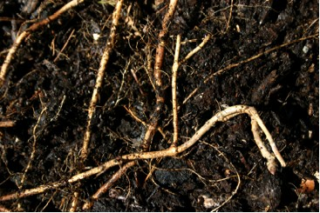

Wild Sarsaparilla Roots

The “roots” of a believer need to be in Christ Jesus the Lord. If growth is to take place and new “colonies” of believers established they need to come from being rooted in Christ. Being rooted and built up in Christ and growing in faith, the Christian is enabled to give thanks over and over for the life-giving strength obtained from the Lord. The Christian abounds in thanksgiving.

Dear Lord,
Help us to realize that by being rooted in you can grow in faith. Thank you for sustaining us through the power we receive from being rooted in you. In your name we pray, Amen

Things to Think About and Do
• Read from the Bible so that your faith may be rooted in Christ Jesus the Lord.
• Give thanks for the life-giving strength that comes from being rooted in Christ.
• Find a patch of Wild Sarsaparilla. Note its size. Learn more about its root system. Learn more about the ways in which Wild Sarsaparilla rhizomes have been used for food and medicine.

