Virginia Waterleaf Hydrophyllum virginianum

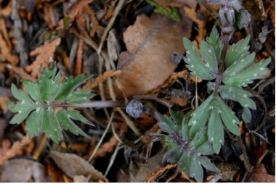

Leaf of Virginia Waterleaf

The leaves of this plant look as if they have been stained by water. Large leaves are divided into pinnate segments and leaflets are toothed. Petioles of lower leaves are longer than those of upper leaves. “The young leaves (before the flowers appear) are excellent boiled for 5-10 min. in 1 or 2 changes of water and served with vinegar.” (Peterson, L., p. 44). The fragile stem is smooth. It can grow to be one to three feet high.
It was first studied in Virginia and therefore is known as Virginia Waterleaf. It often grows abundantly in rich, moist woods as well as in yards and clearings. It blooms from May to August.
Lavender to white bell-shaped flowers hang in clusters from a long stalk that rises above the leaves. The flowers have five petals that are joined at the base. The stamens are long and protrude from the blossoms.

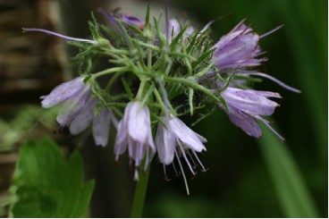

Virginia Waterleaf Flowers

The extensive root system helps the plant survive even if leaves are cut.
The seed capsule contains one or two seeds in each section.

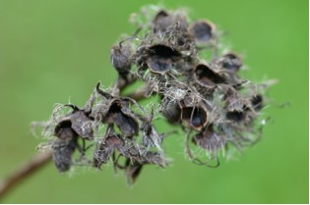

Virginia Waterleaf Seed Pods in August

