Virginia Waterleaf Hydrophyllum virginianum

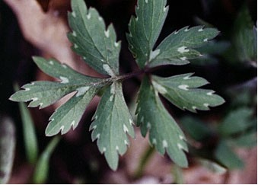

Leaf of Virginia Waterleaf

Jesus answered, “Very truly, I tell you, no one can enter the kingdom of God without being born of water and the Spirit. John 3:5

Therefore we have been buried with him by baptism into death, so that, just as Christ was raised from the dead by the glory of the Father, so we too might walk in newness of life. Romans 6:4 (NRSV)

Water Marks
The leaves of this plant look as if they have been stained by water. It was first studied in Virginia and therefore is known as Virginia Waterleaf.
The appearance of water marks on the leaves of this plant remain while the plant is green and even when the leaves have dried. Christians are born of water and the Spirit. The marks of the “water” of our baptism are carried throughout this life and into eternal life. The name Christian means we are members of God’s family. We are “water-marked Christians”. In this Christian family we are enabled to “bloom and bear fruit”.

Dear Lord,
Help us to remember that in baptism you have marked us and called us. Help us to share your love with others. In your name we pray, Amen.

Things to Think About and Do
• Remember your own baptism. Remember that you have been marked as God’s child and called to work in the Kingdom of God.
• Find Virginia Waterleaf plants. Examine and photograph or draw the plants.
• Mark one plant and watch it through the seasons.

