Common Dandelion Taraxacum officinale

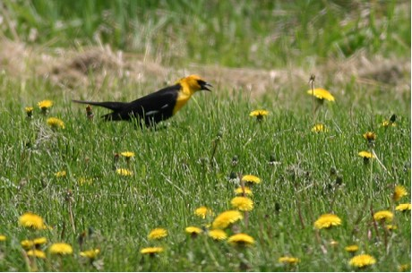

Yellow-headed Blackbird Among Common Dandelions

The Common Dandelion is a member of the Composite Family (Asteraceae). Its English name comes from the Latin Dens leonis or lion’s tooth and refers to the way the side of the leaf looks like the teeth of a lion. Several reasons are given for meanings of the botanical names. “Taraxacum: probably from the ancient Arabic name for the plant, tharakhchakon. Officinale: from Latin meaning generally ‘of the shops’ or ‘sold in the marketplace.” (Runkel, S., & Bull, A., p. 21). “In its botanical name, officinale indicates that it has long been considered a medical remedy.” (Witty, H. (Ed.)., p. 46)
The Common Dandelion was imported from Europe and is now found almost anywhere in cities and rural areas of America. It grows to be two to eighteen inches high. In good ground leaves may grow to be a couple of inches wide and a foot long.
The flower heads are one to two inches wide. They are borne on a hollow stem and if picked exude a milky juice. The blossoms are actually made of many yellow ray flowers that have five tiny petals and both male and female parts. The outer bracts at the base of the flower are turned down or backwards.

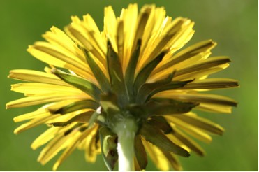

Under Side of Common Dandelion Blossom

One plant may have flowers and seed stages present at the same time. Flowers open in the sun in the morning and close in the evening. On dark days they may not open at all.
“There are three stages in the blooming of each individual flower. First it is completely curled up and closed. Next it opens and a tube elongates out of it. This tube is really the male parts fused together around the female part. Inside this tube the male parts shed their pollen, which is then pushed out by the slender, elongating female part. In the third stage the female part elongates more and opens out into a Y at its tip. In the final stage, the tips of the female part bend around into curlicues.” (Stokes, D., and Stokes, L., p. 142.)

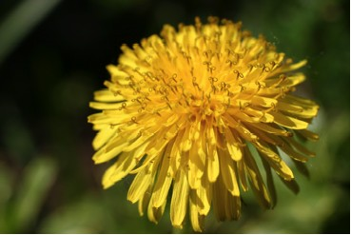

Common Dandelion Blossom

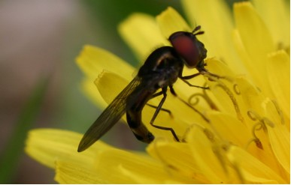

Insect on Dandelion Blossom

The individual flowers do not need to be pollinated to produce seeds. The flower stalk grows longer in preparation for dispersal of seeds. The bracts close around the flower and inside, each small flower produces a brown seed that grows from the female ovule. It is attached to a long stalk and silky parachute that can carry it to distant places. The seed has small barbs that can help it bury itself in the ground. Flowers and seeds appear mainly in spring and early summer but also sometimes later in the season. The wind carries the seeds to many places that gardeners do not want them to grow.

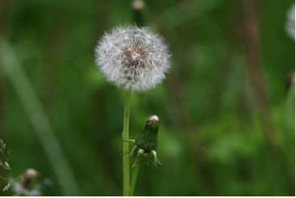

Seeds of Common Dandelion

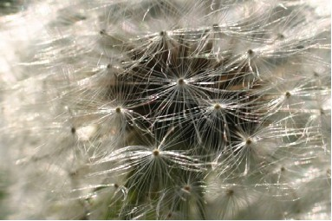

Close-up of Dandelion Seeds

Throughout history the dandelion was an important source of food for people in Europe and the Mediterranean regions. Some sources suggest that dandelions were one of the bitter herbs eaten at the Hebrew Passover. In France dandelions are still raised and sold for food. Many pounds are exported annually from the United States and Canada.
With modern farming techniques and transportation the dandelion has become less important as a source of food.
Wild food recipe books and old cookbooks as well as the Internet give ways to use dandelions as a potherb, to create beverages, fresh vegetable salads, and medicinal tea.
The leaves are rich in more vitamins A and C, potassium, calcium, and iron than many of the vegetables we find in stores. If the leaves are gathered early before the blossoms appear, they will not have the bitter taste some people associate with wild foods. They can be used in salads or as greens on a bread and butter sandwich, or be prepared in a variety of ways as a cooked green. They make an excellent substitute for spinach in a wilted green recipe sautéed with bacon, vinegar and sugar. They can also be substituted for spinach in homemade green noodle recipes. One friend remembers a family tradition when each spring her mother and sisters gather for a meal of buttery mashed potatoes cooked with new dandelion greens. The tender white crowns can be stir fried or used in salads. The flower buds can be picked, cooked and creamed and eaten as a vegetable or included in omelets or scrambled eggs. The golden flowers with every trace of the green bracts removed can be cooked as a vegetable side dish, or used to make fritters or dandelion flower muffins.



Scrambled Eggs With Dandelion Buds

The yellow blossom heads are also gathered by the bucketful to make a very special dandelion wine. There are literally hundreds of recipes for this wine ranging from very detailed to very simple like the one found in an old family cookbook.



Dandelion Wine Recipe from Old Book

The large taproots can be dug in early spring, cleaned, peeled and cooked as a vegetable. More often the roots are cleaned and roasted in a slow oven and then ground and used to brew dandelion coffee.

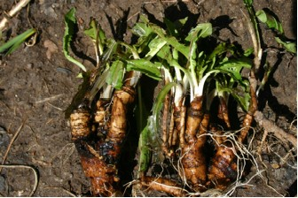

Roots of Dandelion Plants

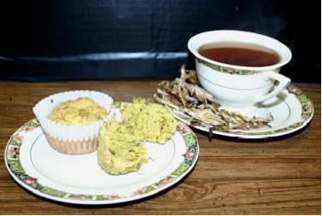

Dandelion Flower Muffins, Roasted Dandelion Roots, and Dandelion Root Coffee

Actually all parts of the plant are edible, but care must be taken to collect it in places where herbicides have not been used. One writer also reminds us of another danger for both wild and cultivated plants in areas of heavy traffic. “Horrifically poisonous lead compounds came streaming out of every exhaust pipe, and, being heavy, settled thickly on surrounding vegetation. Some plants, dandelions among them, fairly soak up lead, making them artificially toxic.” (Henderson, R., p. 16)

Medicinal Uses
From ancient times to the present the dandelion has had many suggested medicinal uses. Even today magazines such as Prevention periodically identify its benefits. Its vitamin and mineral rich leaves are regarded as an important spring tonic. When Europeans brought the plant to America, the Indians also adapted it to medicinal use.
The milky juice from the stems has been applied to warts to make them go away. It is said to be equally or more effective for wart removal than many over the counter or prescribed remedies.
The plant has been used as a diuretic. Folklore identifies its use to treat liver and kidney disorders, gallstones, piles, gout, and rheumatism. It has been recommended to detoxify the body of harmful chemicals, to reduce free radicals, to normalize blood sugar levels and even to stimulate cancer fighting immune cells.
It is important to check with a doctor or health provider to determine if any of these possible uses would be helpful or conflict with prescriptions or conditions for which you are being treated.

Other Uses
Dandelions have been used as a natural dye substance. Depending on which mordant such as alum, washing soda, vinegar, or cream of tarter are used, and the kind of fabric being dyed, the color may vary from grayish purple to a purplish red. If no mordant is used a yellow may result.

Play With Plants
Children have used dandelion plant parts at playtime. The flowers and stems were braided to make crowns and necklaces. The somewhat bitter stem was split into several parts at the end and then moved in and out of the mouth to make “curls”. Playful little boys also used the stem as a horrid sounding noise maker.
Long chains were constructed with each link formed by putting the narrow end of the stem into the somewhat wider part at the base. Children also held a blossom under each other’s chins and asked, “Do you like butter?” If they could see a yellow reflection the answer was, “Yes”. Children enjoy blowing the seeds from the puffy seed head and often invent games such as trying to be the first to blow off all the seeds from their plant or pretending to determine what time it is by how many seeds are left.

Survival
The dandelion plant is wonderfully adapted to survive in many situations. That may be one of the reasons it has become such a despised weed,
Its long perennial taproot is hard to dig and if parts of it remain in the ground those parts can regrow. Its underground food storage enables it to survive harsh or dry winters and return in the spring.
The plant has a small rosette or whorl of leaves close to the ground. The leaves overlap and block out light and moisture available to nearby competing plants. The flat rosette of leaves also escapes cutting by lawn mowers or grazing by animals. Water dropping onto the rosette runs to the center rather than away from the plant helping it to conserve moisture.
The blooms of the plant open and close with varying light conditions, thus protecting the developing seeds. The plant has both male and female parts in the same blossom so it does not need to depend entirely on pollination by insects. After pollination inside the flower head has occurred, the blossom closes for several days to protect the growing and developing seeds. The stem also increases in length so that when the seeds are ready to be released they will be above the surrounding vegetation and will be able to catch the blowing breezes. The seeds are easily carried by small parachutes to many possible new locations. There the little backward facing barbs on the seed help it to dig into the soil.

Benefits
Who, besides those humans who use dandelions for food or medicine, benefits from them? Honey bees and bumble bees use them as an early springtime source of nectar and pollen. Clouded sulphur and other butterflies are attracted to them. Seed eating birds such as goldfinches and turkeys enjoy the seeds and rabbits and other mammals munch the greens. Often as birds and beneficial insects are attracted to a garden they stay to help with pest control and keep a balance in nature.
Diligent lawn owners may try to eliminate them, but there is no doubt that after a long dreary winter most of us will welcome a golden dandelion flower as a wonderful sign of spring. No wonder that some poets and artists have sung its praises.

