Yellow Rocket, Winter Cress (Barbarea vulgaris)

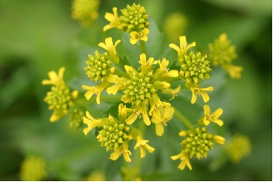

Yellow Rocket Flowers

This European import has spread and become invasive throughout North America. Its bright yellow blossoms cover fields and gardens much to the disgust of those who want to plant other crops. We have memories of pulling and removing wheelbarrows filled with Yellow Rocket from our fields. Our backs ached. Yet, it was an important source of food for our ancestors. “Winter cress is one of those plants once known as scurvy grass that were used to prevent scurvy, that dread disease of long voyages. The greens were dried and rehydrated in a soup for the sailors.” (Witty, H. (Ed.)., p. 107).

“The Latin name, Barbarea, comes from Saint Barbara, whose day is celebrated in early December. Some say the plant is named after her because that’s when the seeds of early winter cress were planted in order to harvest the leaves in spring; others say it is because in December you can already gather some leaves for eating. In any case, the connection for the name may be obscure, but the plant is certainly not.” (Stokes, D., and Stokes, L., p. 345).

The flowers are at the top of straight, leafy stems. As the buds open the flower stalk gets longer.

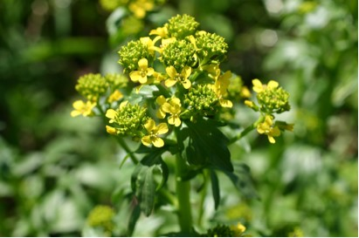

The flowers have four petals that form a cross. The family name, Cruciferae, comes from the Latin word for cross. Flowers in this family have four petals. Yellow Rocket flowers have six stamens. Many small insects come to gather nectar and pollen from the flowers.

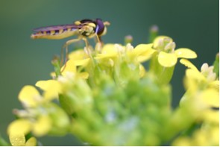

Insect on Yellow Rocket Flowers

Lower leaves are rounded with small lobes. Upper leaves are more coarsely toothed. The plant can get to be one to two feet high. In fall and early spring the leaves are formed in a rosette.
Many seeds are produced in narrow, linear pods in summer. “The fruit is typical of all of the Mustard family and is called a silique. It has two sets of seeds separated by a thin membrane called a replum. When the two outer halves of the fruit split off, the seeds are sprung out. The replum, which is often translucent, remains on the plant.” (Stokes, D., and Stokes, L., p. 348). The seeds germinate quickly. The stalk dies and new leaves are produced at the base.
We have used both the young leaves and colorful blossoms in salads. The leaves can also be cooked as greens. Birds enjoy eating the seeds.

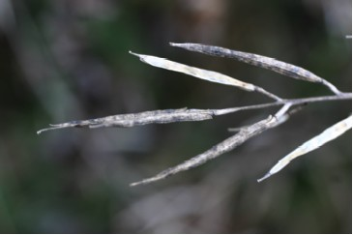

Ripe Yellow Rocket Seed Pods

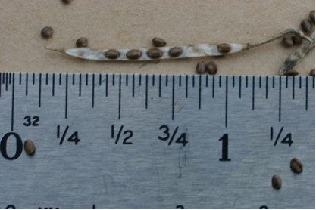

Yellow Rocket Seeds

