Yellow Rocket, Winter Cress (Barbarea vulgaris)

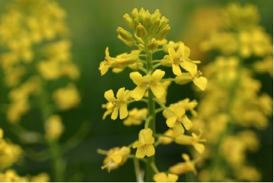

Yellow Rocket Flowers

Keep your lives free from the love of money, and be content with what you have; for he has said, “I will never leave you or forsake you.” Hebrews 13:5 (NRSV)

Point of View - Contentment With What We Have

This plant has been seen as both friend and foe. By eating it sailors prevented scurvy. By harvesting it our ancestors obtained a fresh vegetable when others were not yet ready for harvest. It was so important to them that they brought it from Europe to North America. They were happy and content to have it in their new gardens. Then it spread in gardens and fields and smothered other crops. Farmers saw it as an enemy. We too saw it as a weed until we began to add it to bland commercial greens to create refreshing, nourishing spring salads.
Learning to appreciate, manage, and use sources of food that cost no money can cut down the size of grocery bills and add vitamins to the diet. It is a small part of being free from the love of money and being content with what we have. Might Yellow Rocket plants and other wild edibles help needy people manage tight budgets? What effect does our point of view have on wise use of the gifts we have been given? When can we use what we have and be content?

Dear Lord,
Help us to learn about many sources of food available to us in the places where we live. Open our eyes to new ways of seeing plants in our environment. Help us to use wisely the gifts we have been given. In your name we pray, Amen.

Things to Think About and Do

• What does it mean to each of us to keep our lives free from the love of money and be content with what we have?
• Examine ways of using wild foods as a way to cut the costs of food and to enrich the diet.
• Thank God for the many sources of good food that are available in your local environment. Learn to appreciate those foods.
• Examine books about wild foods and learn to identify those available in your area. Check with people who are knowledgeable about plants and let them assist with identification and preparation.
• Learn about various members of the Cruciferae family that are commonly grown in vegetable gardens. (Cabbage family)

