Clintonia or Bluebead-Lily (Clintonia borealis)

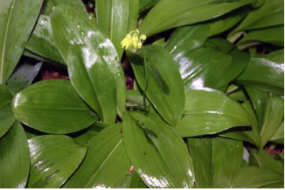

Clintonia Leaves and Flowers

Governor Dewitt Clinton of New York who encouraged the building of the Erie Canal between 1817 and 1825 also had a great interest in botany. The Clintonia bears his name. It is a member of the Lily Family.
Clintonias can commonly be found in moist to wet woods. For years we had some that grew under a White Pine tree among the pine needles. The plants prefer acid soils and can grow to be a foot or more high.
The light green, oval leaves are large and shiny.
The nodding yellowish-green flowers have six sepal divisions, six stamens and a light green pistil. A few flowers form on a leafless stalk that is longer than the leaves.

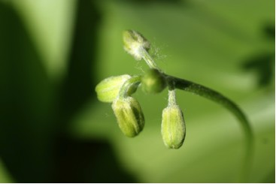

Clintonia Buds

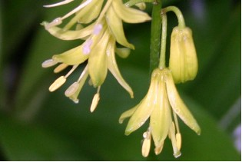

Clintonia Flowers

The Clintonia is also known as the Bluebead Lily because when the berries ripen in August they are bead-like in appearance and a beautiful shade of blue. In fact botanists warn that blue berries of such intense color are to be avoided as poisonous. On the other hand, some persons collect the young leaves as a wild food. “Before fully unfurled, the young leaves can be added to salads or boiled for 10 min. and served with butter. As the leaves mature, the cucumber taste becomes harsh and unpleasant.” (Peterson, L., p. 74). The plant is not too common so it may be best to enjoy its beauty rather than its possible food uses.

