Cut-leaved Toothwort (Dentaria laciniata)

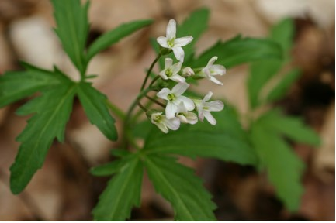

Cut-leaved Toothwort Flowers and Leaves

May I never boast of anything except the cross of our Lord Jesus Christ, by which the world has been crucified to me, and I to the world. Galatians 6:14 (NRSV)

The Cross
People who research their family names often find that they are linked to the early appearance, interest, location or occupation of a distant ancestor. Characteristics among people can be genetically traced and used to verify relationships and origins.
The Cut-leaved Toothwort belongs to the Cruciferae family with about 1,800 species. This family got its name from the fact that flowers of plants in this group have four petals arranged in the shape of a cross. Examine the flowers of the radish, broccoli, or mustard and this four-petal, cross arrangement will be seen.
Christians belong to the family of God, the cross, bearing family. They “lift high the cross” and proclaim the love of God to others.
As we look at the Cruciferae family and members of it like the Cut-leafed Toothwort we can remember and proclaim our own identity. We can love because we have been loved by the one who went to the cross, died for us and now lives forever. Because he lives we too shall live.

Dear Lord,
Help us to lift high the cross and through your love and power love others around us. In your name we pray, Amen.

Things to Think About and Do
• Tell others about what the symbol of the cross means to you.
• Identify and find plants that are part of the Cruciferae family.
• Research your own family names. What are the origins of those names?
• Find a Cut-leaved Toothwort plant and watch it through its growing season.

