Canada Mayflower Maianthemum canadense

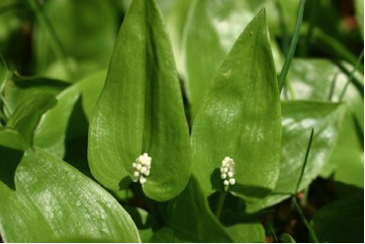

Canada Mayflower Buds

This wildflower is found in Canada and far south into the United States.
Maianthemum comes from the Latin words for May and flower. Its leaves and growth pattern are somewhat like that of the Lily of the Valley and it is sometimes called “False Lily of the Valley”. Both are members of the Lily Family.
This perennial grows abundantly in woods and lawns where it spreads by rhizomes and seeds. It grows from three to six inches high. Not all plants in a dense carpet of ovate shaped leaves have flowers. White fragrant flowers may appear from May to June on plants with more than one leaf.

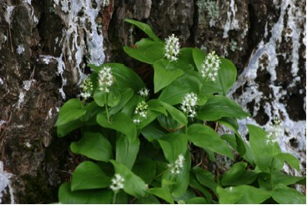

Canada Mayflower Flowers Near a Pine Tree

The flowers have two petals, two sepals and four stamens.

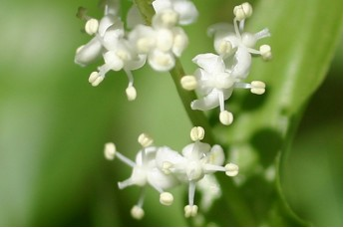

Close-up View of Canada Mayflower Flowers

In summer the fruits look like miniature speckled bird eggs but later they darken and turn red. Inside are one to three pearly white seeds. The fruits are eaten by birds and small rodents.

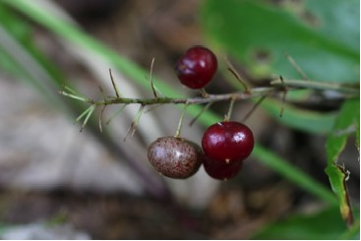

Canada Mayflower Berries in September

In fall the fine roots may have small, attached tubers that store food for the plant in winter. New shoots already begin to appear on the large rhizomes in fall and will come out soon in spring.

