Canada Mayflower Maianthemum canadense

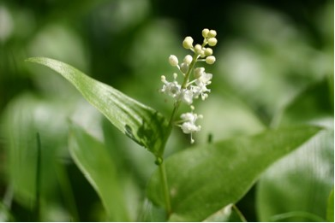

Canada Mayflower Leaves and Blossoms

Consider the lilies of the field, how they grow; they neither toil nor spin, yet I tell you, even Solomon in all his glory was not clothed like one of these. But if God so clothes the grass of the field, which is alive today and tomorrow is thrown into the oven, will he not much more clothe you – you of little faith? Therefore do not worry, saying, ‘What will we eat?’ or ‘What will we drink?’ or ‘What will we wear?’ For it is the Gentiles who strive for all these things; and indeed your heavenly Father knows that you need all these things. But strive first for the kingdom of God and his righteousness, and all these things will be given to you as well. Matthew 6:28b-33 (NRSV)

Members of the Same Family

This wildflower is a member of the Lily Family. Its leaves and growth pattern are somewhat like that of the Lily of the Valley and it is sometimes called “False Lily of the Valley”. A few of the other wildflowers that are members of this family are Bellworts, Turks-cap, Tiger, Day, and Fawn Lilies, Clintonias, Trilliums, Wild Onions and Garlic, Solomon’s Seal and False Solomon’s Seal. On a global scale the Lily Family has about 2,500 species. Scientists have placed them in the same family because of common characteristics.
Members of the same human families share common characteristics. Physical appearances are passed on from generation to generation. Learned characteristics are also shared and passed on.
In the family of God some are related by physical birth. All are related by spiritual birth. They have been baptized and marked with the cross of Christ forever. They all have the same Heavenly Father who cares for them. They have all been called to work in and for the Kingdom of God. Jesus told us that the “lilies of the field” have the special attention and care of our Heavenly Father. If God cares so much about plants we know too that we are and will be loved and cared for by our Heavenly Father as we work together in the Kingdom.

Dear Heavenly Father,
Help us to trust you for all that we need in this life and the life to come. Guide and lead as we work together in the family of God. In Jesus’ name, Amen.

Things to Think About and Do
• Look in a wildflower book that lists plants by family. Make a list of all the members of the Lily Family that grow in your area. Why did scientists group them as members of the same family?
• Count the leaves on Canada Mayflower plants that have flowers and those that do not. What differences do you see?
• Examine the flowers of the Canada Mayflower with a magnifying glass or hand lens.
• Observe the fruits of the Canada Mayflower as they develop. Note the changes in color.

