Blue Cohosh Caulophyllum thalictroides

Blue Cohosh is easily overlooked in the woods in spring. When the tightly curled leaves first emerge they have a rich purple color. The leaves have nine leaflets arranged in groups of three and look much like those of a Meadow Rue plant and therefore it has the species name of thalictroides. The leaves also resemble those of the columbine plant. As the leaves mature they become a delicate blue-green color and may be up to two feet across. It is a member of the Barberry Family. (Berberidaceae)

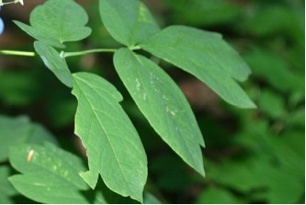

Part of a Blue Cohosh Leaf

It grows well in rich, moist, limestone soils and can be from one to three feet high. It flowers from April through June.
The roots are thick and matted. Its inconspicuous flowers have six greenish-yellow sepals with a thick, tiny petal and nectar glands inside each sepal. There are six stamens and a pistil at the center.

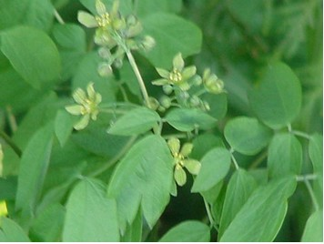

Blue Cohosh Flowers and Leaves

It is in late summer or fall that it begins to attract attention with its deep blue seeds that have a waxy sheen. The seeds may take a year or more to germinate.

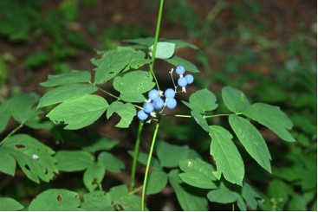

Blue Cohosh Seeds in August

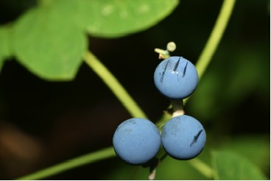

Blue Cohosh Seeds

Native Americans did not think of it as a plant to be overlooked but found it useful for young, expectant mothers. Its name, Cohosh, is a Native American word. Pioneers also found medicinal uses for it.

