Blue Cohosh Caulophyllum thalictroides

Plants as a Gift From the Creator

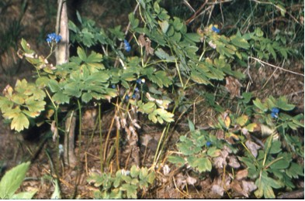

Blue Cohosh Plant

God said, “See, I have given you every plant yielding seed that is upon the face of all the earth, and every tree with seed in its fruit; you shall have them for food. And to every beast of the earth, and to every bird of the air, and to everything that creeps on the earth, everything that has the breath of life, I have given every green plant for food.” And it was so. God saw everything that he had made, and indeed, it was very good. Genesis 1:29-31a (NRSV)

God’s Gifts Are Good

Before modern research people relied on knowing the special properties of plants to help cure their diseases. Knowledgeable “botanists” were highly respected in their communities. They knew that God had provided a great variety of wonderful foods and medicines in the plant kingdom.
Now researchers identify and reproduce chemical compounds like those in plants to produce medicines in large quantities for many people. Searches still go on to find new drugs in plants that have been known to be helpful.
The importance of vitamins, minerals, and other nutrients in plants continues to be crucial to good health.
Some see the beauty of a plant and want it as a part of their garden. Blue Cohosh is a nice plant for a shade garden.
Authors give food and medicinal uses for Blue Cohosh. Such suggestions should always be checked in many sources and the user should be certain that the right plant is being used.
Some suggestions and cautions found are given here.
Many Native American tribes used this plant to help pregnant mothers have a painless delivery. (Runkel, S., & Bull, A., p. 47).
“Pioneers tried blue cohosh treatments for rheumatism, epilepsy, colic, and many other disabilities. At one time, roots and rhizomes were actively collected for use by early pharmacists in preparing medicines.
The berries, if eaten, are irritating to mucous membranes – and may cause other troubles. One report, however, indicates that the berries can be roasted and used as a sort of coffee substitute. Some people develop a rash from contact with the plant.” (Runkel, S., & Bull, A., p. 47).

Dear Lord,
Thank you for your gifts of medicines and nutrients in plants. Help us to use your gifts wisely to heal and maintain healthy bodies. In your name we pray, Amen.

Things to Think About and Do
• Examine the shelves in a grocery or health food store to see how many medicines have plants as a source.
• Look at the foods in the produce and other departments in a grocery store to identify their plant sources.
• What plants are grown for foods in gardens in your area?
• What wild plants are used as sources of food in your area? (Wild berries, fruits, leaves, and roots)

