Wooly Blue Violet (Viola sororia)

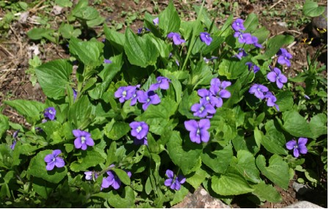

Wooly Blue Violet

Violets belong to the genus Viola and the family Violaceae. The Wooly Blue Violet, Viola sororia, is a species with stemless purple flowers and hairy, heart-shaped leaves.

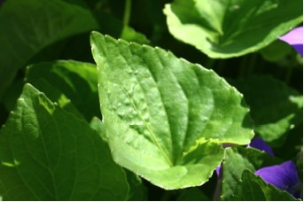

Wooly Blue Violet Leaves

“Stemless” means that the leafstalks come directly from underground rootstocks. “Leafy-stemmed” violets have leaves that come from a common stem. The Wooly Blue Violet is perhaps the most common blue violet in the Eastern United States. It grows in Zones 3 to 9 in woods, clearings, and yards in sunshine or shade. In tall grass it can grow to be ten inches tall and also survives despite being cut short in lawns. It thrives in rich, moist soil. In summer and fall the plant produces petalless, cleistogamous flowers that do not open, are self-pollinated and produce many seeds. Cultivars of the Wooly Blue Violet include “Freckles” and “Princeana”. ‘Freckles’ has pale blue flowers flecked with purple. ‘Princeana’, the confederate violet, has white flowers with purple-blue centers.” (Burrell, C., p.162). There are many species of violets.
The Wooly Blue Violet has five petals. There is one above, one on each side, and a wide lower petal with a spur on the back that contains the nectar.

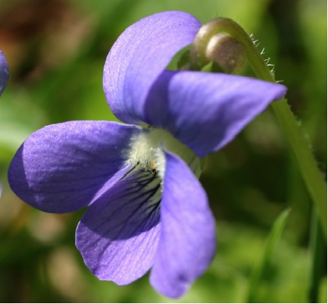

Wooly Blue Violet Flower

Bees “usually land on the bottom petal and then turn upside down and hold on to the top petal before sticking their head into the flower center. It is fun to watch them do this little flip every time.” (Stokes, D., and Stokes, L., p. 334). As insects follow the nectar guides, they reach through the opening with the anthers and pistil. In the process they are covered with pollen, which is then transferred to other blossoms.
Violet leaves are rich in vitamins A and C. Try using them in salads. The flowers add color to a tossed salad and can also be candied or made into jelly.
The larvae of Fritillary Butterflies also benefit from the vitamin rich leaves. Watch for the beautiful Great Spangled, Variegated, or other Fritillary butterflies that may frequent the areas where violets grow. “The larvae hatch out but then hibernate through winter without eating anything. In spring they begin to feed on the new leaves and continue their life cycle.” (Stokes, D., and Stokes, L., p. 331).

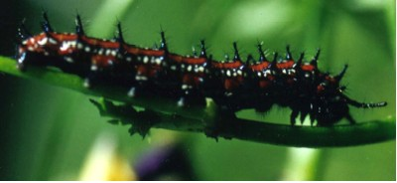

Variegated Fritillary Butterfly Larva

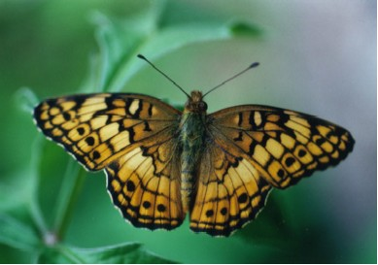

Variegated Fritillary Butterfly

