Wooly Blue Violet (Viola sororia)

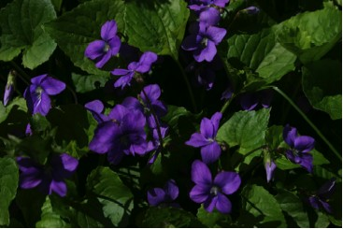

Wooly Blue Violets

Your steadfast love, O LORD extends to the heavens, your faithfulness to the clouds. Psalm 36:5

Thy faithfulness endures to all generations; you have established the earth, and it stands fast. Psalm 119:90

The steadfast love of the LORD never ceases, his mercies never come to an end; they are new every morning; great is your faithfulness, Lamentations 3:22-23 (NRSV)

God is Faithful

The Wooly Blue Violet is perhaps the most common blue violet in the Eastern United States. It faithfully comes up in woods, clearings, and yards in sunshine or shade.
The flower has five blue or purple petals. There is one above, one on each side, and a wide lower petal with a spur on the back that contains the nectar. The leaves are hairy and heart-shaped.
Violets have often been used to convey special messages. They have symbolized friendship, faithfulness, and modesty.
The Bible reminds us that the Lord is faithful! His great faithfulness extends to the clouds and endures to all generations.

Dear Lord,
Thank you for loving us and faithfully caring for us. Help us to trust you at all times. In your name we pray, Amen

Things to Think About and Do
• Bouquets of flowers have often been used to convey messages. Violets have been used to symbolize friendship, faithfulness, and modesty. Learn about other flowers and the messages they have been used to share.
• Find poems that have been written about violets. Write some of your own poetry about violets.
• Note how the flowers and leaves are on separate stems. Compare this violet to others that grow in the area. Are there “stemless” as well as “leafy-stemmed” violets? What shapes are the leaves of the various violets? Are the leaves toothed?
• Count the petals and sepals on each violet.
• Look for the lines or nectar guides for insects.
• How do the violets change in color as they get older?
• Wooly Blue Violet blossoms and leaves can be added to salads. When you are certain that you have correctly identified the plant try tasting the leaves and flowers.
• Watch for butterfly larvae that use violet plants as a host.

