Downy Yellow Violet (Viola pubescens)

This plant has soft, hairy leaves and lemon yellow flowers that form on stems. It grows to be six to sixteen inches high. It grows in Zones 3 to 8 and blooms from May to June. An abundance of seeds help this plant spread. The heart-shaped, toothed leaves come from a common stem and therefore the Downy Yellow Violet is grouped among the “leafy-stemmed violets”.
The flowers have five sepals and five petals. Insects can land on the broad lower petal that has a spur at the back containing the nectar. As the insect follows the lines pointing to the nectar it moves among the anthers and pistil, becomes covered with pollen and carries this to other flowers.

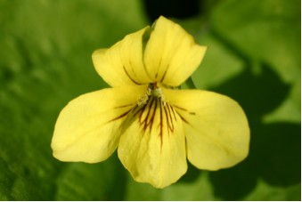

Downy Yellow Violet Flower

The seedpods have three lobes that each contains a double row of seeds. When ripe, the pods open, curl back, and scatter the seeds.

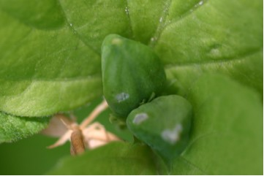

Downy Yellow Violet Seed Pods

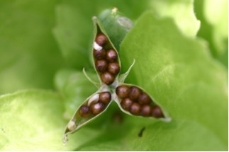

Downy Yellow Violet Seeds

