Downy Yellow Violet Viola pubescens

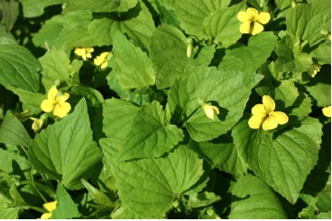

Yellow Violet Flowers and Leaves

Follow the Signs
How do we know where to go when looking for something? How do insects know where to find nectar? Scientists tell us that the lines on flowers point to the sources of nectar. The dark lines on a yellow violet point to the nectar at the end of the spur. Insects follow the lines and find a sweet reward.
How do we find direction for our lives? The Psalmist prayed, “Lead me in your truth and teach me, for you are the God of my salvation; for you I wait all day long.” Psalm 25:5. (NRSV)
God’s Word gives us guidance and nourishment. The Psalmist wrote, “ How sweet are your words to my taste, sweeter than honey to my mouth! Through your precepts I get understanding:” Psalm 119:103-104a. The Word of God provides us with guidance and nourishment.
As we look at the lines that lead to nectar in a flower we are reminded that we can be led and guided to God’s word.

Dear Lord,
“Lead me in your truth and teach me, for you are the God of my salvation; for you I wait all day long.” Amen.

Things to Think About and Do
• Find the lines that lead to nectar in various kinds of flowers. Watch for various kinds of insects that come to the flowers and note how they enter and leave.
• Look for the nectar spur on violets.
• Make a list of the violets found in the area where you live. Learn about each of them. Describe the area in which each grows. How do they differ from each other?
• Draw a picture of the Downy Yellow Violet and note special identifying characteristics in the drawing. (Shapes, sizes, and colors of leaves, stems, flowers, seeds, and roots)
• Visit a violet plant that you marked over a period of several weeks. Keep a journal of the changes you observe. How long does the blossom last? What do the seeds look like? How are the seeds scattered?
• In what kind of habitat does the plant seem to grow best?

