Wild Oats or Merrybells (Uvularia sessilifolia)

We called them “Hanging Bells”. This flower formed large patches under our spruce trees where their small, straw-colored bells waved in the breezes. They liked the acid soils found under these coniferous trees and could be found blooming there from April to June.

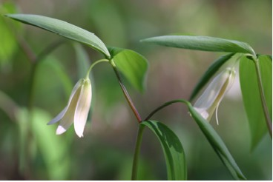

Wild Oats Flowers and Leaves

The angled stem is branched and has unstalked, light green leaves. It grows to be eight to twelve inches high.
Wild Oats is a member of the Lily Family and is related to the larger, bright yellow, Large-flowered Bellwort Uvularika grandiflora.
Sometimes people thought the use of a plant was related to its shape. “At one time these plants were thought to be good for treating throat diseases because the drooping flowers resembled the uvula, the soft lobe hanging into the throat from the soft palate.” (Niering, W., p. 613).

The fruit is a triangular pod that contains round seeds.

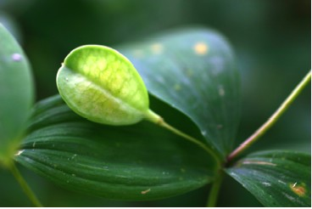

Wild Oats Seed Pod

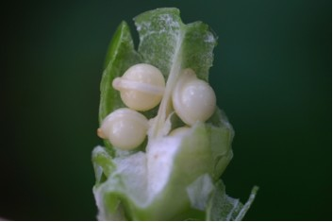

Seeds Inside Wild Oats Seed Pod

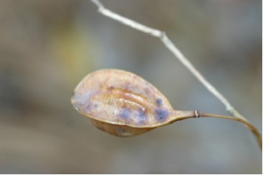

Ripe Wild Oats Seed Pod

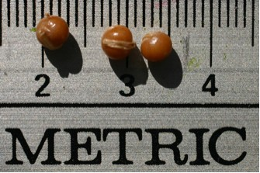

Wild Oats Seeds

Creeping rhizomes help the plants spread.

