Wild Oats or Merrybells (Uvularia sessilifolia)

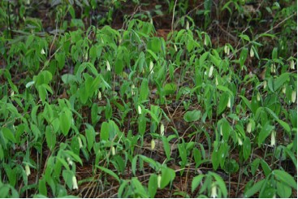

Wild Oats Plants in Bloom

O come, let us worship and bow down, let us kneel before the LORD, our Maker!
Psalm 95:6 (NRSV)
Bells

Bells call people together for worship services at churches in many lands. Each bell has its own tone and worshipers recognize the tones. Some sound when a person pulls a rope and others play electronically. Skilled musicians play large carillons. Regardless of the tone or place the bells say, “Come”!
The small Wild Oats bells sway silently but yet seem to beckon us to come, kneel, appreciate, and give thanks. When we are called to worship by the bells of a church we are invited to come, kneel, appreciate, and give thanks for all of the Creator’s gifts to us.

Dear Lord,
Help us to listen to the call of “bells” that beckon us to worship you. In your name we pray, Amen.

Things to Think About and Do
• Learn about the various wildflowers in your area that are members of the lily family. Make a list of them. What made botanists place them together in a group?
• Examine the various parts of Wild Oats plants at different times of the year. Record observations in words or pictures.

