Nodding Trillium Trillium cernuum

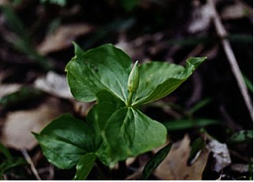

Nodding Trillium Bud

Nodding Trillium Trillium cernuum

The nodding white to pinkish flower on a short stalk with recurved petals is less showy than that of Trillium grandiflora that blooms at the same time. Cernus is the Latin word for drooping or nodding. The flower is hidden beneath three whorled green leaves. The three sepals are pale green and the six stamens have anthers that are pale lavender or pink. It is frequently found in moist to wet acid woods. It grows to a height of six to twenty-four inches.

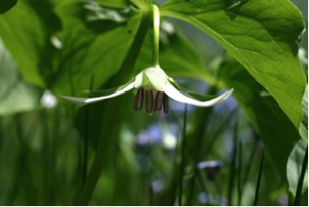

Nodding Trillium Flower

The fruit is a fairly large berry that turns reddish-purple when ripe.

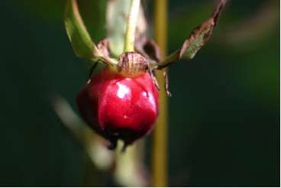

Nodding Trillium Fruit

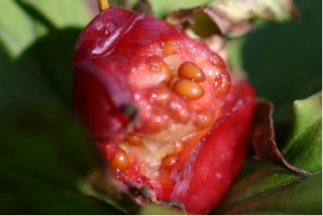

Nodding Trillium Seeds Inside Fruit

