Nodding Trillium Trillium cernuum

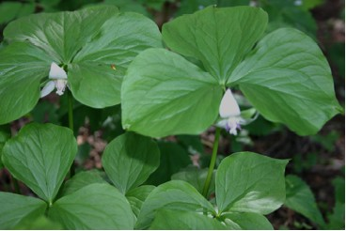

Nodding Trillium Leaves and Flowers

You did not choose me but I chose you. And I appointed you to go and bear fruit, fruit that will last, so that the Father will give you whatever you ask him in my name. John 15:16 (NRSV)

Showy or Quiet
In all families there are those who attract a lot of attention and those who are quiet and less showy. The trillium family has a quite a number of different kinds of plants in its family. The less showy Nodding Trillium is less likely to draw attention as people pass by. It is not likely to be chosen first by people who want to add new flowers to their gardens. If it could express feelings it might be those of a child who is not chosen first by friends. Yet in a world where it relates to insects that come to pollinate it is not less important. Insects readily find it and in late summer it produces a large, beautiful fruit. It has a special place of importance.
Often we judge by outward appearances and beauty. The Bible tells us that the fruits Christians bear are important. Are there people who do not work in a showy manner and yet produce much fruit in the kingdom of God?

Dear Lord,
Work in us to produce much fruit for your kingdom. In your name we pray, Amen

Things to Think About and Do
• Learn about the various members of the Trillium family. Use the Internet or books about wildflowers. Note the flowers as well as the fruits of each.
• Take pictures of the various stages of growth of the Nodding Trillium.

