Wild Ginger
Wild Ginger (Asarum canadense)

Wild Ginger is a member of the Birthwort family. It blooms in April and May.

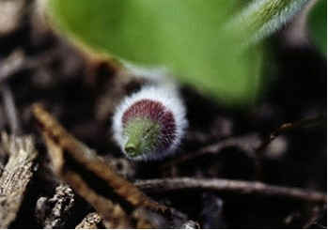

Wild Ginger Bud

The flower forms at ground level between and beneath two hairy, heart-shaped leaves. The flower is cup shaped, pale in the center, and maroon or reddish-brown on the edges and outside. It has three pointed lobes.

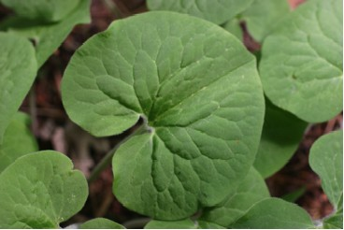

Wild Ginger Leaves

Sometimes the flowers lie under leaf litter and are pollinated by beetles. (Fields, p. 80).

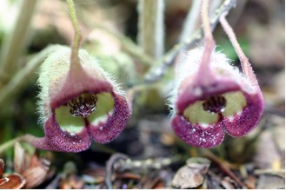

Wild Ginger Flowers

By fall the seed ripens in fall inside a six-celled, mealy fruit. It splits and turns inside out when ripe. Some fall around the base of the plant. Ants may pick up the seeds from the mushy pulp and carry them away, thus helping in the propagation process. (Cullina, p. 246)
The root has a ginger-like odor and can be cooked with sugar and used as a substitute for ginger. (Niering, p. 349). Early settlers who did not have ready access to ginger, which belongs to a different plant family, did this.
In some states Wild Ginger is on a protected species list. If you are in an area where harvesting is permitted do that with care. Always leave pieces of the root where you find it. Even broken pieces of root will survive and multiply.
The roots can be washed and spread on a baking sheet in a 200-degree oven for a few hours. They can be stored in an airtight container and crushed with a pestle or snipped with a shears before use.

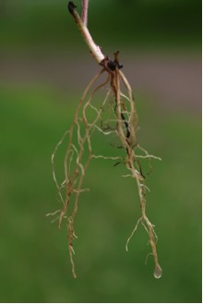

Wild Ginger Root or Rhizome

“In early medicine, wild ginger was highly regarded as a treatment for whooping cough. It has also been used for digestive stomach upset, chest complaints, fevers, heart palpitations, and many other ailments.” (Runkel and Bull, p. 43) Some Native American tribes chewed the root and then moistened their lures with the substance to attract more fish.

