Jack-in-the-Pulpit (Arisaema triphyllum)

In spring a pointed plant containing leaves and a flower emerge from the ground.

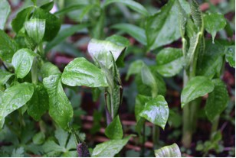

Jack-in-the-pulpits Emerging in Spring

The covering unfolds and leaves and a flower that looks something like a green calla lily emerges. The green or green and brown wildflower has a flap-like green or green striped with purplish-brown spathe that looks like an old-fashioned church pulpit. The spathe droops at the end and hides the spadix or preacher or Jack inside.

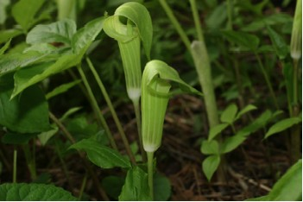

Jack-in-the-pulpit Flowers and Leaves

There are tiny flowers at the base of the spadix. Staminate and pistillate flowers are often on separate plants. Some references say that both male and female flowers can be found on the same plant. Male flowers bear the pollen. The flowers at the base that look like small green berries are female and those that look like they are shedding pollen are the male flowers.
Small flies are attracted to the flower and crawl down inside. Perhaps they follow the stripes to the bottom of the flower, get covered with pollen and transfer that to female portions of a flower.

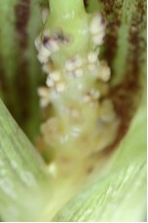

Male Jack-in-the-pulpit Flowers

The one or two long-stalked, compound leaves resemble those of the trillium but the veins are slightly off center whereas those of the trillium are centered. Young plants have one leaf and mature plants have a pair of leaves composed of three leaflets. The leaves contain calcium oxalate and are rarely eaten by animals.

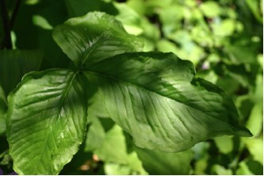

Jack-in-the-pulpit Leaf

The plants can grow to be one to three feet tall.
After the flower has bloomed and been pollinated the spathe and spadix wither. Female flowers mature into a cluster of green and later scarlet berries. Seeds fall to the ground nearby and animals disperse others. It takes four years for a seed to grow and mature into a flower-bearing plant.

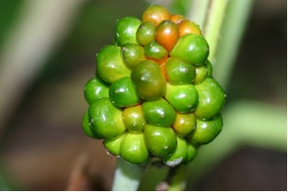

Partially Ripe Jack-in-the-pulpit Berries

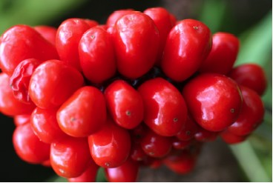

Ripe Jack-in-the-pulpit Berries

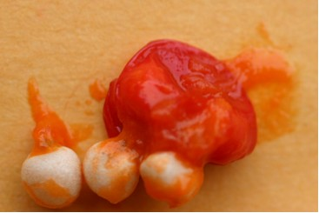

Seeds Inside Jack-in-the-pulpit Berry

At the base of the plant there is a large corm with roots coming from it. New corms can grow off of it and eventually produce new plants. A large corm with much stored food can produce two leaves and a female flower the following year. Smaller corms may produce only one leaf or a plant with a male flower the next year. A corm that produces a male flower one year may produce a female flower the next.
Native Americans boiled the corms in several changes of water to remove the calcium oxalate and then were able to eat them. The plant was sometimes called the “Indian Turnip”.

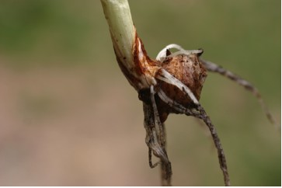

Jack-in-the-pulpit Root

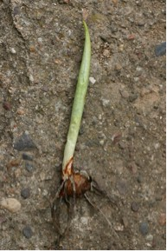

Jack-in-the-pulpit Root and Sprout

