Jack-in-the-Pulpit (Arisaema triphyllum)

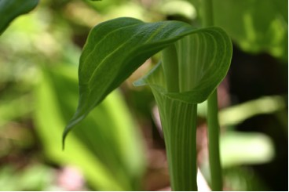

Jack-in-the-pulpit Flower

But he said, "Blessed rather are those who hear the word of God and obey it!"
Luke 11:28 (NRSV)
Preacher in the Woods

Messages from the Pulpit
This flower has inspired people to call it a preacher. In times when electronic microphones were not available and people stood during church services the clergy needed to be high above the congregation in order to be able to project their voices. Ornate pulpits with steps leading to them stood out like flowers on a stem. When people found this flower in the woods they thought of their churches and the messages they heard there. They heard that if God cared enough to clothe small flowers like this surely a loving God would care for them too.

Dear Lord,
Help us to remember important messages about you that we have heard from pulpits in the churches we have attended. Help us to trust in your loving care. In your name we pray, Amen

Things to Think About and Do
• Watch the growth and development of several Jack-in-the-pulpit plants throughout the seasons. Record what you see.
• Look for and draw the various parts of the plant. Label the parts.
• Take pictures of the various stages.
• Read more about this plant and add to your own notes.
• Write your own message about what the plant “says” to you.
• Try writing poetry about the plant.

Jack-in-the-pulpit

Little preacher of the wood
Standing straight and tall;
God created blooms like you
And dressed you one and all.

God’s love and care
Is shown in how you’re dressed.
If god cares for wild plants like you
We too can trust and rest.

Loretta Kuse

