Large-flowered Trillium or Common Trillium (Trillium grandiflorum)

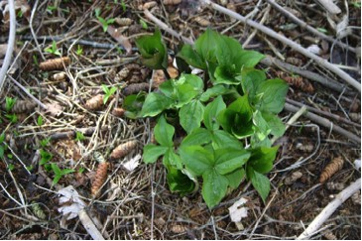

Large-flowered Trilliums Coming Up in Spring

In our childhood the woods in late May were full of hundreds of large, waxy white flowers that covered the forest floor. Grandma in her German diary called these trilliums “wild lilies” and also commented that on May14th and 22nd in 1927 and again on May 22nd in 1940 these flowers were numerous and in full bloom. (Freckman, 1994) gave the earliest blooming dates as April 24^{th.}

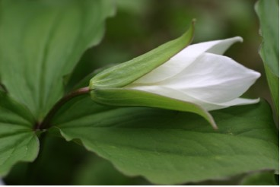

Large-flowered Trillium Bud Opening

Today, with more houses and lawns in the country, and fewer undisturbed woodlots those visions of white are less frequently seen. In addition, the White-tailed Deer population has steadily increased and their appetite for tasty trilliums has served to eliminate many stands of this beautiful plant. This is especially troublesome because once the leaves and flowers are plucked, the plant is likely to die. It can no longer produce food to send down to the roots so that it can come back another year. It still grows quite abundantly on the sloping bank along Billings Avenue in the Town of Medford, Wisconsin. Some sources say that deer do not like to graze on steep banks or inclines so that may be why those plants have escaped.
We have a patch of trilliums that has grown larger each year in our lawn. Recently we have had to protect these trilliums from the deer that could wipe out the entire patch in a single night. Sometimes seeds from those plants, possibly transported by ants, have grown into new plants in the front lawn. We dig them up and put them where they will not be mowed off. We have also planted some behind the garage near the Hemlock tree so that they would be better protected from the deer. We continue to move others that have come up in open areas to places where they will be better protected from deer. We have also collected seeds from some of the older plants and sown them in new locations. Such seeds should be sown right after they are collected. The young plants send up only one leaf during their first and second years and do not have the typical three leaves until the third year. They may not flower until the plant is five or six years old.

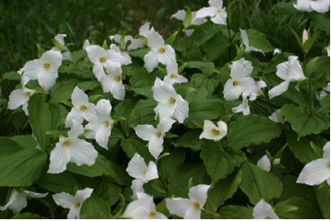

Large-flowered Trilliums

The name trillium comes from the Latin tres that means three and lilium for lily. The mature plant has three leaves, actually bracts, three petals, and three sepals.

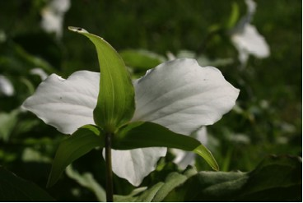

Large-flowered Trillium Showing Three Green Sepals

There are about twenty-six species of trilliums in North America. Locally in Taylor County and on our land we have the Large-flowered Trillium Trillium grandiflorum and the Nodding Trillium, Trillium cernuum. (Fields, p. 160)
The Large-flowered Trillium is also known as the Common Trillium, Snowy Trillium, White Trillium and Birthroot.
Some Native Americans chewed the roots of the plant for various medicinal purposes. The name Birthroot came from the fact that they, as well as some pioneers and herbalists used substances from the rootstalks of some species of trillium as a help in childbirth. It was also used as an antiseptic.
The flowers are pure white at first, but turn pink before the seeds form. Usually they bloom for about two weeks.

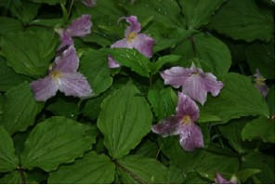

Large-flowered Trilliums at the End of the Blooming Season

The pistil, or female part of the plant, is large and has six lobes. At the top of the pistil are three stigmas. There are six stamens or male flower parts that have long yellow anthers. They surround the shorter female parts. Watch to see which beetles and flies come to visit the flower and serve as pollinators. The interdependence of the insects and flowers and the timing when both the right insects and the blooming period of the plants are available is one of the wonders of creation.

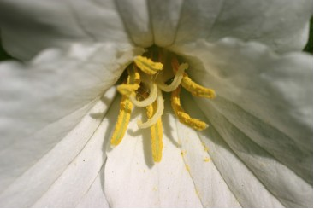

Close-up View of Large-flowered Trillium Blossom

The fruit of the trillium is a fleshy, pale green berry or capsule with ridges on the outside. It is smooth on the inside where yellow-green seeds are packed tightly in three compartments. The capsule is about 3/4 inch across. As the seeds mature the stalks bend down closer to the ground. Pressure from the growing seeds on the inside causes the capsule to split open on one side. The sticky seeds then fall out of the capsule in clusters. This usually happens in late July, about eight or ten weeks after flowering.

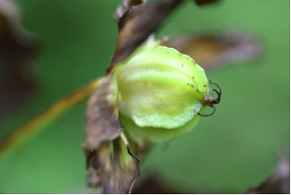

Large-flowered Trillium Seed Capsule

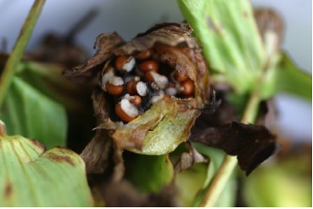

Seeds Inside Capsule or Berry of Large-flowered Trillium

The seeds of the trillium along with those of several other plants are special because they have a ridge of material almost the size of the seed attached to the outside. This is called an elaiosome or strophiole. Ants are very attracted to it and carry it along with the seed back to their nesting area. There they eat the strophiole, but leave the seed. According to Stokes (p. 313) ants have been observed carrying the seeds as far as thirty feet from the original plant.

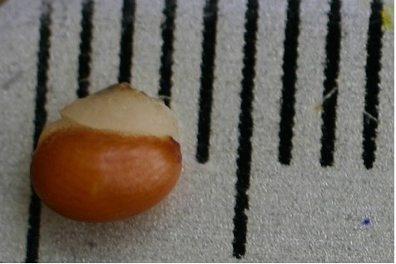

One Seed of the Large-flowered Trillium with Strophiole on the Exterior

If seeds are carried away by ants or planted where we hope to have them grow, they will not germinate until the next spring. Then the seed will send out a root and over-winter underground. The following year it will send up a single leaf or cotyledon. Because the growth conditions for these woodland plants are limited to the short time when sunlight reaches them before the trees leaf out, it may not develop into a plant with three leaves for another year or more. Even then it may not flower until about six years have passed.
Trilliums have fleshy rhizomes or rootstocks. Late in summer new buds will grow on those rhizomes. Next year’s leaves and flowers grow in these buds and over-winter underground.
If trilliums are purchased for wildflower gardens they should be obtained from nurseries that propagate their own plants rather than dig them from the woods. Because it takes so long to grow from seed some less environmentally conscious firms are tempted to dig wild plants and contribute to their reduction in numbers. When moving plants in your own woods or garden, or when rescuing them from property that is being developed, it is best, if possible, to transplant them in late summer after their leaves have withered. The plants grow well in rich woods. In a wild flower garden adding a mulch of rotted leaves or other organic matter at the beginning and end of the growing season is helpful.
Even though some wild food sources say the leaves of the plant can be used as greens, this seems very unwise because taking the leaves is likely to kill the plant. Picking the flowers has the same devastating result because the leaves are located directly under the flower and are picked with it.

••••••••••••••••••••••••••

Trillium
Wild lily
Standing solemn, still
Providing beauty, sharing joy
Liliaceae

Trillium
Large flowered
Fragile, tender, tall
Wondrous, waxy, white flower
Grandiflorum

Trillium
Triple trumpet
Three green sepals
Waving, nodding, blooming, growing
Lily

Trillium
Green berry
Many tiny seeds
Slowly ripening, turning yellow
Capsule

Trillium
Woodland wonder
Ripe yellow fruit
Brilliantly glowing, shining
Wildflower

Loretta Kuse

