Large-flowered Trillium or Common Trillium (Trillium grandiflorum)

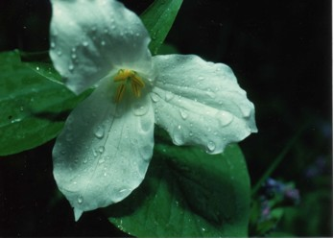

Large-flowered Trillium With Raindrops on Blossom

I will greatly rejoice in the LORD, my whole being shall exult in my God; for he has clothed me with the garments of salvation, he has covered me with the robe of righteousness. Isaiah 61:10

Do you not know that all of us who have been baptized into Christ Jesus were baptized into his death? Therefore we have been buried with him by baptism into death, so that, just as Christ was raised from the dead by the glory of the Father, so we too might walk in newness of life. Romans 6:3-4

There is therefore now no condemnation for those who are in Christ Jesus. Romans 8:1 (NRSV)

Garment of Righteousness

The trillium has three white petals and three leaves. It can remind us of the Trinity, Father, Son, and Holy Spirit. As we look at its white petals we can think of the white robe of righteousness with which we are covered because of what Jesus has done for us. When we were baptized into Christ Jesus we were baptized into his death. Through the water and the Spirit we can walk in newness of life.

Dear Heavenly Father,
Thank you for forgiving and loving us and covering us with a white robe of righteousness. Send your Holy Spirit to strengthen our faith and help us to rejoice in the new life you have given us. In Jesus’ name, Amen

Things to Think About and Do

• Keep a journal of the changes you see and the times they occur in the life of a trillium plant for one season,
• Use a computer search engine to note the ways wildflowers, especially trilliums have been portrayed in art. Make your own drawing or painting to show what you like about the plants.

• Compare the flower parts of the trillium with those of a tulip, also in the lily family. You might find some tulips that can be picked and taken apart for closer observation of the various parts. Then sketch or photograph similar parts in the trillium. Can you locate and label the petals, sepals, pistil, stamens, anthers, and ovary?

•Watch to see which kinds of insects come to visit the flower.

• Do the flowers have a fragrance?

• Think of words that would describe a trillium. How could you use those words in a poem or in a hymn of praise?

