Wild Blue Phlox (Phlox divaricata)

The word phlox comes from the Greek word meaning “flame” and divaricata refers to the Latin word meaning divergent or spreading. The creeping plants and their flower heads spread or branch out.
The lance-shaped leaves form on opposite sides of erect, hairy stems. The plants grow to be ten to twenty inches high. Shoots spread from the base of the plant.
The flat, wedge-shaped, purplish-blue flowers have a trumpet-shaped corolla and five notched petals. The five short stamens, one pistil and three stigmas do not protrude from the blossoms. The flowers are slightly fragrant.

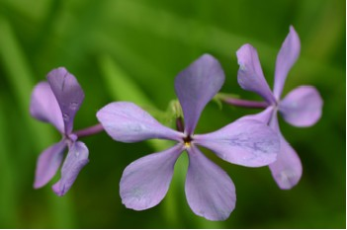

Wild Phlox Flowers

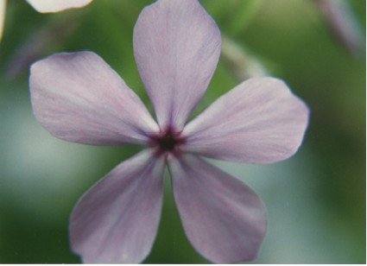

Blossom of Wild Phlox

One seed forms in each of the two or three compartments of the oval capsule.
It blooms at the same time as the Large-flowered Trillium and Wild Geranium and together they provide a spectacular display of blooms. This wildflower was once abundant in nearby woods but now has almost disappeared. It is uncertain what changes in the environment caused the disappearance of the plant.

