Spring Beauty (Claytonia virginica)

This member of the Purslane family covers large areas with delicate pink blossoms in spring. It truly provides “beauty” in spring.
Its scientific name, Claytonia virginica, was first given in Virginia in honor of John Clayton, an early American botanist and physician. There are thirteen species in North America.
Years ago we planted a few near our house and now, before the leaves come out on the trees above them, a great portion of our lawn is covered with a carpet of these flowers. We leave the grass unmowed until the plants go dormant.

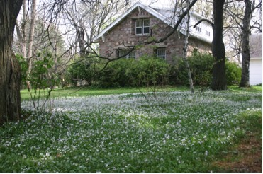

Spring Beauties Blooming in the Lawn

The white or white tinged with pink blossoms that measure about a half-inch across have red stripes and from a distance the flowers look pink. The stripes on the blossoms may guide insects to the pollen at the center.

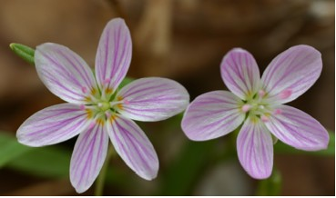

Spring Beauty Blossoms

The flowers are arranged in rows along the stem and open when the sun is bright. Usually only a few are open at one time. The fragile plants have grasslike leaves that are smooth and thick.

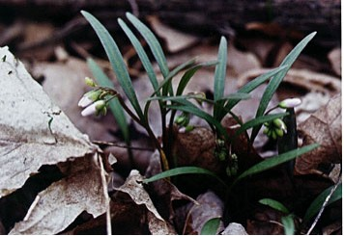

Early Spring Beauty Leaves and Buds

Spring Beauties are also known as “Fairy spuds” because their tiny roots look like potatoes that might be eaten by small creatures of the woods. Large and small mammals enjoy eating the roots. The enlarged, slightly flattened root may range in size from a quarter inch to an inch and a half in diameter. Indians and early pioneers used the root either raw or boiled as food. It is said to have a bland flavor or to taste something like chestnuts. Larger mammals enjoy eating the above ground parts. According to Thayer, “While not as well known as the fairy spuds, the greens of spring beauty are likewise an excellent food source. They are mild in flavor, thick, juicy, slightly crisp, and not stringy. I frequently use the greens in salads, and they are also good cooked. When speaking of the greens, I am referring to the entire portion of the plant that grows above ground: stems, leaves, and flowers.” (Thayer, S., p. 199.) Harvest with care and enjoy the taste of a few but leave the rest to beautify the area.

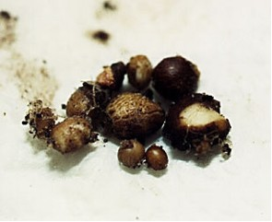

“Fairy Spuds”

Small, shiny black seeds are produced in pods created by the two sepals on the stem. Sometimes as the pods dry the seeds are expelled to some distance from the plant.

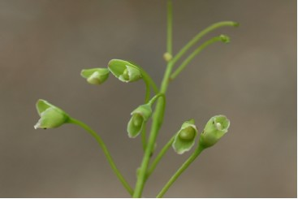

Spring Beauty Seed Pods

Soon after the seeds ripen the plants disappear and the roots lie dormant for about ten months. For that reason the plant is known as one of the spring ephemerals. It is a good example of a “sleeping beauty”

