Spring Beauty (Claytonia virginica)

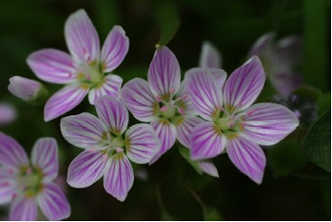

Spring Beauty Blossoms

Beauty
For from the greatness and beauty of created things comes a corresponding perception of their Creator. Wisdom of Solomon 13:5 (NRSV)

What caused people to give this plant a name like “Spring Beauty”? We hear that “beauty is in the eye of the beholder”. The colors of the petals, the succulent green leaves, the expanse of massive plantings that look pink, or the tiny stamens covered with pink pollen are all things that make this plant “beautiful” to the beholder.
Beauty for the insects that pollinate the flowers may be in the lines that serve as nectar guides. Beauty for the animals that eat the leaves or roots may be in the taste or smell of the plant.
Beauty for the photographer or artist may be interpreted as particular angles or portions are chosen to reproduce. Beauty for the scientist may come as a result of analysis of the changes and growth patterns of the plant.
What point of view did and does our Creator have of the Spring Beauty? Does the Creator want each of us to behold with our eyes in unique and individual ways? Could it be that the “eye of the one who beholds us” rejoices as we enjoy what has been created?

Dear Lord,
You created and saw that what you made was GOOD. You rested from your work and enjoyed it. Help us to come aside and rest a while and behold the beauty of the earth. In your name we pray, Amen.

Things to Think About and Do
• Choose one Spring Beauty plant and observe changes in it over time. Keep a journal or record of the changes.
• Why do you think the plant should be named Spring Beauty?
• Make a list of beautiful things God has created.
• Try writing a poem about beauty that you see.
• Look at the hymn “For the Beauty of the Earth”. Sing the song. Write your own prayer or song of thanks to God for the beauty of the earth.
• Look at the Bible verse again. What “perception of the Creator” do you get by looking at a beautiful flower?

