Common Buttercups Ranunculus acris

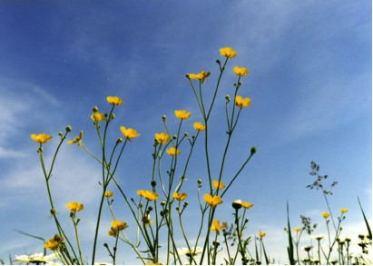

Common Buttercups Ranunculus acris

General Descriptions of the Plant
The name Ranunculus which means little frog was given by Pliny, an early botanist. He noted that buttercups grew where little frogs lived. (Stokes, p. 58) The leaves of the plant resemble the foot of a bird and therefore the genus is also called Crowfoot. The name "buttercup" seems appropriate because the flower looks like a shiny bit of butter.
This plant is also listed in a German nature guide. (Eisenreich, p. 146). The German name, Scharfer Hanenfuß, translates as sharp rooster’s claw and may refer to the shape of the leaves. Early settlers brought it to this area. We wonder what settler brought seeds and how they spread. It must have been seen as an attractive garden plant.
Members of the Ranunculus species already existed in America before the arrival of European settlers. Native Americans used them as medicine for a variety of illnesses. Ranunculus acris was imported and therefore would not have been among their earliest herbal remedies.
Animals avoid eating the plant because the leaves and stems contain a sharp tasting or bitter juice that can be poisonous to them. The plant is not poisonous to the touch and can be picked and placed in flower bouquets.
The plant is tall and can grow among other tall meadow plants. It can easily raise its leaves high to receive energy from the sun. Stokes states that "Underground it has a very short rhizome that grows a new rosette each year, the older part of the rhizome decaying behind it. Because of this method of growth, you rarely see a whole colony of the plants; rather, they are usually isolated individuals." (Stokes, p. 59.)
The flowers usually have five petals and five green sepals. Insects come to drink the nectar produced at the base of the petals. Flowers stay open for several days. The petals have a waxy layer on top. Underneath is a layer of yellow and beneath that a layer of white cells. These white cells make the yellow look brilliant. The center of the flower does not have the added white cells under the yellow cells. (Stokes, p. 61)

Where We Found This Plant Growing

Appreciation and Memories
In poorly tended farm fields and pastures this "weed" grew in greater abundance than farmers wanted it to grow. Its petals were a beautiful, shiny yellow. Seeds later were arranged in a spiky cluster. It grew well with the ox-eye daisies. We learned to associate the two with each other and regarded them with disdain because that was the way farmers felt about them. They were poisonous and the cows would not eat them. Later in life we began to appreciate the golden flowers, the patterns of the green leaves, and noted the brownish pattern superimposed on the green. The leaves were really rather pretty.
This flower can be found in moist places in the pasture and hay fields.

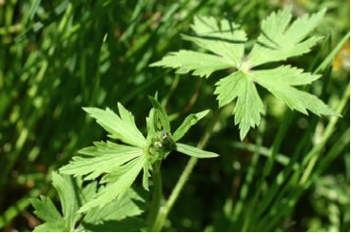

Common Buttercup Leaves and Buds

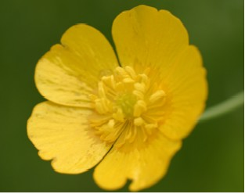

Common Buttercup Flower

The seeds of this perennial germinate in spring or fall. The mature plant overwinters and produces more leaves in spring.

Propagation
This plant seems to need no assistance in propagation. It often spreads to places where it is not wanted and is considered by some to be a weed.

