Common Buttercup (Ranunculus acris)

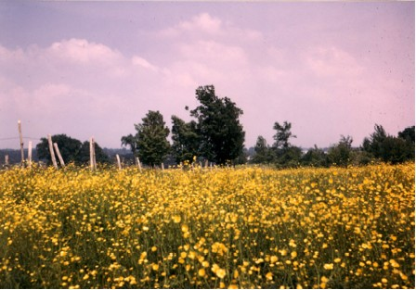

A Field Covered With the Common Buttercup

For whatever was written in former days was written for our instruction, so that by steadfastness and by the encouragement of the scriptures we might have hope. Romans 15:4 (NRSV)

God Raises Hope
God raised grass; God raised flowers.
Come, come and see.
God raised the downcast.
Come, come, and be free.

God raised a prophet; God raised a king.
Come, come and sing.
Raise your eyes; raise your hands.
Come, come your praises bring.

God raised Jesus up from the grave.
Come, come with hope.
God will raise believers.
Come, come and live in hope!

Loretta Kuse

God Raises Hope Within Us
This tall Common Buttercup raises its slender stems and golden blossoms to the sky. It appears to raise them in hope of receiving sunshine and energy. Shiny petals of the flower open to the sun and seem to say, " I am open to what God gives. My petals reflect the light that shines on them."
We too can raise our hands to God, accept God's goodness, and know that God gives us hope. We know that the light of the Son of God can be reflected in our lives.
Hope has been given to us and we share it with others.

Dear Lord,
Remind us each day of the hope we have for this life and the life to come. Thank you for loving and forgiving us and for promising to give us eternal life. In your name we pray, Amen.

Things to Think About and Do
• Learn about this and other plants that were brought to America from Europe.
• Learn about plants that farmers try to eradicate. Find out why they want to be rid of them. Why may some of them grow more vigorously here than in the countries they came from?
• Learn about other members of the Ranunculus family.
• Look for the part of the petal that has the waxy layer of cells on top, the layer of yellow and the layer of white cells underneath. Compare it to the part of the petal that does not have these layers.

