Wood Anemone Anemone quinquefolia

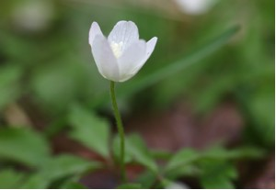

Wood Anemone

The name Anemone comes from the Greek term meaning “wind”. Sometimes the flowers are called “Wind flowers” perhaps because they tremble in the breeze on their slender stalks.
This six to twelve-inch perennial grows in dry to medium woods and on lawns.
“In any group of the plants, you will see two types of individuals: those with flowers and those without. Those without flowers appear to have five small leaves, hence the specific name quinquefolia, which means ‘five-leaved.’ The plants with flowers usually have three sets of leaves, each with three leaflets.” (Stokes, D., and Stokes, L., p. 18) Small plants sometimes have less leaflets.
Writers use different terms to describe the leaves. Runkel and Bull call them bracts. “There are three dark green, palmately divided leaves (actually bracts) with five parts each about half way up the stem. “Each leaf-like bract has its own petiole. After flowering, a basal leaf develops. The outer two of its three parts are so deeply cut it often appears five-parted to casual observation.” (Runkel, S., & Bull, A., p. 27)

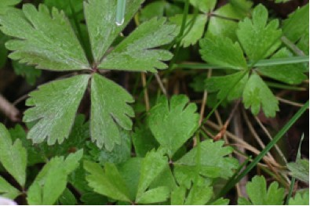

Wood Anemone Leaves or Bracts

The flowers have four to nine white sepals that are often pink on the reverse side. They can be from one-half to one inch wide. They open during the day and close at night or on cloudy days. The flower nods downward when it closes. There are numerous stamens and pistils in the center. The flowers stay open for several weeks.

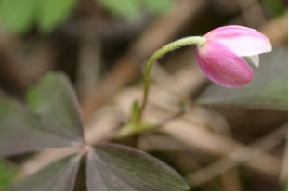

Wood Anemone Blossom

Faint lines on the sepals may serve as guides to help insects find nectar.

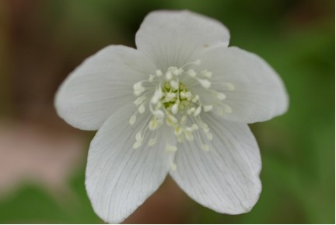

Wood Anemone Flower

After they are pollinated by insects the flowers turn brown and fall off. Fruits form and fall off the plants in a few weeks. Leaves remain a little longer but then are also shed.
The rest of the summer, fall, and winter the plant goes dormant. It spends time under the ground as roots and fleshy rhizomes. New shoots grow from these each year.

