Marsh Marigold or Cowslip (Caltha palustris)

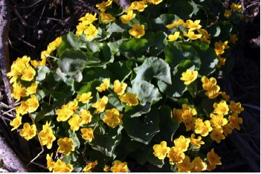

Marsh Marigolds

Our ancestors in Europe and Asia were familiar with the Marsh Marigold as it also grew in marshes, moist meadows, and near streams in their home areas. Germans knew it as “Sumpfdotterblume” (Sumpf = marsh; Dotter = yolk of egg; Blume = flower). Indeed its color is similar to that of the yolk of an egg.

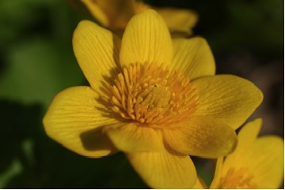

Marsh Marigold Flower

We knew it by the common name of “Cowslip”. It grew in swampy spots along the path where the cows stepped and slipped as they were driven to and from the pasture. One source gave this reason for the common name. “The term cowslip is probably from ‘cow slop’ indicating that the plant grows better where cows have dropped their dung.” (Runkel, S., & Bull, A. p. 37). The plants grow well in rich soil.
Its scientific name, Caltha palustris had Greek and Latin sources. “Caltha: from old Greek, and later Latin, meaning ‘chalice’ or ‘cup’. Palustris: from Latin meaning ‘of the marsh’ in reference to where the plant is usually found.” (Runkel, S., & Bull, A. p. 37).

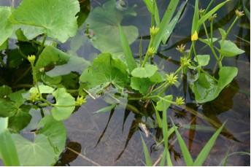

Marsh Marigolds in Pond

Furrowed, hollow, and somewhat angular stems are branched and have smooth, glossy, heart-shaped leaves with long petioles. Lower leaves can become as much as eight inches across. Upper leaves are smaller.

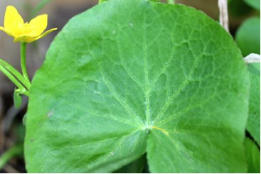

Marsh Marigold Leaf

The one to one-and-one-half-inch cup-shaped flowers have from five to nine bright-yellow, oval sepals but no petals.

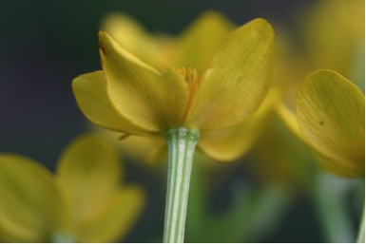

Underside of Marsh Marigold

Many stamens stand above the nectar glands. Insects get covered with pollen as they push the stamens aside.

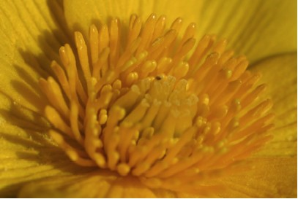

Stamens of Marsh Marigold Flower

This perennial has fine rootlets that anchor it to the soil.

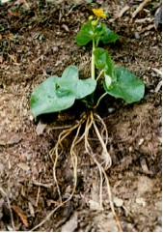

Marsh Marigold Roots

The whorl of greenish-brown seed pods turns yellow and then dark when they ripen. Then they split open along one side. Seeds can float on water to new places.

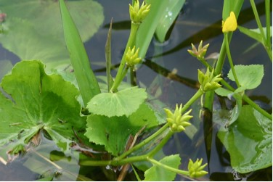

Marsh Marigold Seed Pods

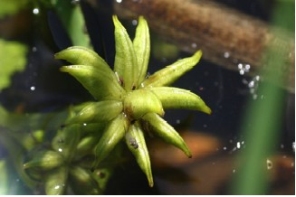

Marsh Marigold Seed Pods

One writer indicated that both the flowers and leaves were used in various ways.

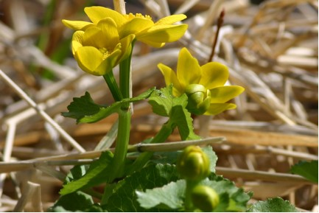

Marsh Marigold Flowers and Buds

“English farmers have made cowslip blossom wine since Saxon times, as well as a pulpy jam for scones. The flowers were also crystallized … used fresh in salads, and ground into a moist meal to be mixed with honey for a dessert filling. Unopened cowslip buds can be pickled, and the leaves are used fresh as salad greens.” (Henderson, p. 86) Others do not recommend eating the leaves raw but rather that they be cooked and the water poured off to destroy a toxic alkaloid. “Livestock have been poisoned by eating excessively of the plants when other forage was unavailable.” (Runkel, S., & Bull, A. p. 37). Writers also give various medicinal uses.

