Marsh Marigold or Cowslip (Caltha palustris)

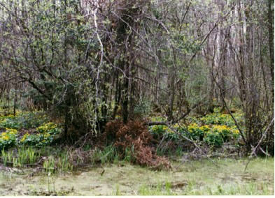

Marsh Marigolds in Swampy Area

Rich or Poor

Through the centuries people have desired the riches of gold and silver. They want the precious metal so that they can purchase things that make them happy. The writer of the book of Proverbs said, “A good name is to be chosen rather than great riches, and favor is better than silver or gold.” Proverbs 22:1 (NRSV)
What might cause us to have a “good name”? Our reputations are more important than having a lot of “gold” or riches. For what are or will we be known?
• Will we be known as people who point others to Jesus who is more precious than gold or silver, the source of our hope and joy for this life and forever?
• Will we be known as people who brought joy to others in need?
• Will we be remembered as people who could find joy in the beauty of nature around us?
God has given us “gold” in the gift of Jesus, great blessings when we give to others, and great joy when we appreciate the “gold” in the beauty of nature around us.
The joy that is felt in spring when viewing a marsh covered with “Marsh Marigolds” is something that poor and rich alike can enjoy. As we become aware of the gifts we have been given and the “gold” around us and share our joy with others our lives and the lives of others are enriched.

Dear Heavenly Father,
Make us aware of the “golden” treasures around us. Help us to share our joy with others. In Jesus’ name, Amen.

Things to Think About and Do
• Make a list of the things that are more precious than “gold” in your life.
• Look for gifts of “gold” in the beauty of nature.
• Make a list of all the bright yellow blooms that you see in spring. Share your feelings about the “gold” you find around you in nature.
• Take pictures of Marsh Marigolds in various stages of growth.
• Locate on a map the various places in the world where people can enjoy the “gold” of Marsh Marigolds.

