Wild Geranium Geranium maculatum

Plant characteristics influenced both the common and scientific names of the Wild Geranium or Geranium maculatum. The seedpod looks like the bill of a crane. The Greek word for crane is geranos, hence the name geranium. Maculatum refers to the spotted leaves that older plants sometimes have.
The Wild Geranium grows well in sunshine or partial shade in woods and meadows. It prefers slightly acid soil.

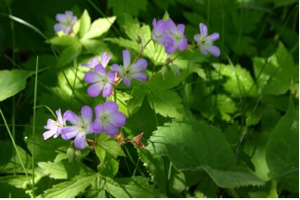

Flowers with five sepals and five petals form on slightly hairy, branched stems. Each flower measures from one to one and one-half inches wide.

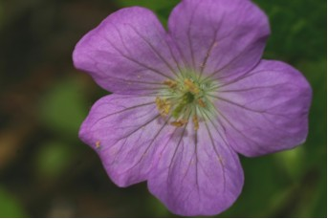

Wild Geranium Flower

Find the Nectar Guides on this Wild Geranium Flower

Flowers have ten stamens with anthers that change color as the flower matures. There are light lines on the pinkish-lavender petals that serve as nectar guides that lead to the center of the flower where tiny hairs on the sepal protect the nectar spot.

The deeply cut, palmately lobed leaves turn from green in spring to shades of red and orange in fall. Large leaves are at the bottom of the plant and smaller leaves near the base of the flowers.

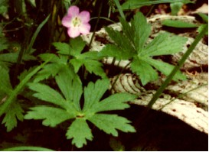

Wild Geranium Leaves

The thick woody rhizomes have leaf scars from previous seasons’ growth and some slender attached roots. New plants grow from the tips of the rhizomes.

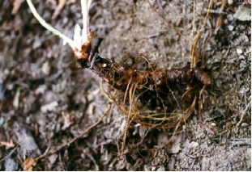

Rhizomes of the Wild Geranium Plant

As seedpods mature, lengthen and dry, fibers inside begin to coil. Tension cause the pods to snap and small, smooth, oval, dark brown seeds are ejected a distance from the plant. Cold weather stratifies the seeds. It may take more than a year for them to germinate. After the third year a new plant may produce blossoms.

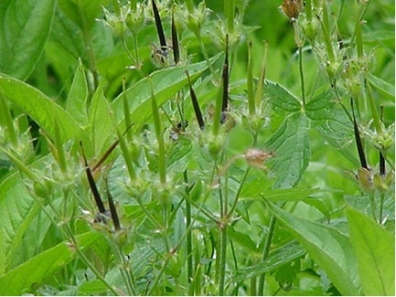

Wild Geranium Seed Pods

Both Native Americans and pioneers found medicinal uses for the plant

