Wild Geranium Geranium maculatum
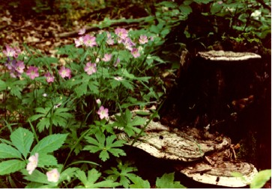

Wild Geranium Geranium maculatum

Blooming Where Planted and Spreading Seeds

He first found his brother Simon and said to him, “We have found the Messiah” (which is translated Anointed). John 1:41 (NRSV)

John the Baptist told two of his disciples that Jesus was the “Lamb of God”. One of the disciples was Andrew. Andrew was so excited to hear that Jesus was the “Lamb of God” that he told his brother, Simon, that they had found the Messiah. Each of the people in the story told someone close by about Jesus. They told the story to their own friends and family. The good news about Jesus spread.
The phrase, “Bloom where you are planted” is often used to tell people to work to do their best right where they are. They are to do this with whatever gifts they have been given.
The Wild Geranium stands tall in the spring sunshine. It cannot move from where its stout rhizomes firmly hold it in place. It “blooms where it is planted!” Yet, it uses a unique seed pod to eject seeds quite a distance from the mature plant. It does what it is intended to do right where it grows.
Each of us lives in a particular time and place. We can share the seeds of God’s love right where we are by using the gifts and ways God has given to us. God can take our words and examples and use them in new ways.

Things to Think About and Do

• Pray that God may lead you to share the good news of Jesus’ love through you right where you are.
• Find a patch of Wild Geraniums. How close together are the plants? How far have the seeds been spread to create new plants?
• In what types of environments are Wild Geranium plants found?
• Look at wild and garden variety members of the Geranium family. Note the shapes of the seedpods. Do they look like cranes’ bills?
• Count the sepals and petals on Wild Geranium flowers. Examine the stamens and anthers. Note color changes as the flowers mature.
• Look for the nectar guides on flowers that lead to the nectar spot.
• Examine the leaves on the various parts of a Wild Geranium plant. Note differences and likenesses. Watch to see how the leaves change through the seasons.
• Observe ripe seedpods. Watch them coil and expel seeds.

