White Trout Lily (Erythronium albidum)
Yellow Trout Lily (Erythronium americanum)

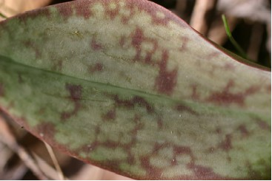

Leaf of the White Trout Lily

In early spring large patches or colonies of smooth shiny leaves of about six to eight inches in height and mottled in shades of brown and green appear in rich woodlands and meadows and even in lawns and pastures. These are the leaves of the Yellow or the White Trout Lily. Its name, Trout Lily, probably comes from the resemblance of the leaves to the colors of a trout or even from the fact that it blooms during trout fishing season. Another name, Fawn Lily, suggests the spotted markings of a young deer or the way the two leaves stand up as they would on an alert fawn. The name, “Adder’s Tongue”, refers to the long stamens in the blossom, which look like the protruding tongue of a snake. Others say the way the stem emerges from the ground in the spring reminds them of an adder’s tongue. In Medieval times when the appearance of certain parts of a plant supposedly suggested its medicinal uses the plant was seen as a remedy for snakebite. Another common name, Dogtooth Violet, comes from the tooth-like appearance of the underground so-called corm of the plant. The plant is not a violet but a member of the lily family.
Both the Yellow Trout Lily Erythronium americanum (ee-ree-THROW-nee-um ah-mer-i-kay-num) and another species, the White Trout Lily, Erythronium albidum, are found in Taylor County (Fields, p. 159) and also in the Kuse Nature Preserve. The yellow form is more common here and also in the eastern states while the white one is more numerous across Iowa (Runkel, p. 45) and to the west. The Lewis and Clark expedition in 1804 had seen others of this plant in the Rocky Mountain region. One near the edge of the snow line is known as Glacier Lily, Snow Lily, or Avalanche Lily. There are fifteen different species of this genus with all but one of them in the United States.
The Trout Lily is among the spring ephemerals, those plants that bloom in early spring before the deciduous trees under which the colonies may grow have leafed out. Once the leaves of the trees shade the plants the flowers and leaves die back. The leaves appear several weeks before the plants flower and may linger a little longer in sunny spots but in summer the leaves die down. The plant is hardy in zones 3 to 8. It may flower from late March until April or May depending on the area where it is found. Here in northern and central Wisconsin its earliest flowering time was recorded at April 27^{th.} (Freckmann, 1994)

Flowers

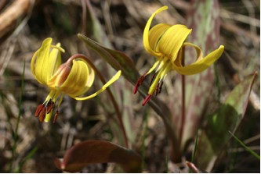

The solitary, nodding flower is at the end of a single leafless scape or flower stalk that may be up to eight inches tall. As is true for most members of the Lillaceae (li-LE-A-CEE-e) family, its flower and seed parts come in groups of six.

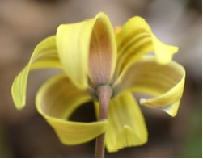

Yellow Trout Lily

There are three petals and three thicker, petal-like sepals. The sepals and the petals look so much alike that it seems as if the flower has six petals. The sepals are yellow in the inside and darker on the back whereas the petals are all yellow except for a darker color along the midrib. Together these six parts are called tepals or the perianth.

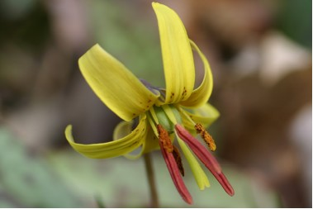

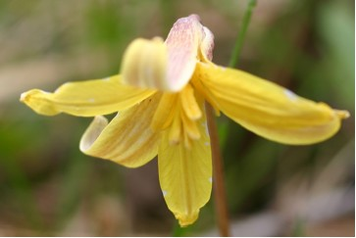

The Yellow Trout Lily seems to have two distinct forms; one with large flowers, bearing yellow stamens; the other small, with flowers bearing brown stamens.

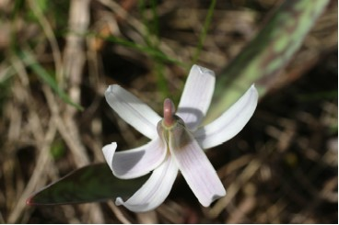

White Trout Lily

The white-flowered species, E. allbidum, has a similar six-parted bloom, but the blossoms are white with a tinge of pink or sometimes shades of purple or blue.

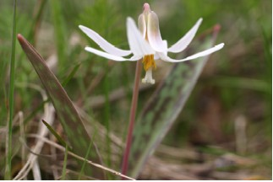

The flower is a hermaphrodite, which means it has both male and female organs.
Some writers call the plant “Thousand Leaf” because it is often found growing in colonies with many leaves and only a few flowers. This happens because many younger plants have been produced from underground runners. These have only one tiny leaf. Even after two or three years they still have only one somewhat larger leaf, but they form colonies of plants near the parent plant. They do not begin to produce flowers until the plant has two leaves and may be seven or eight years old.

Underground System

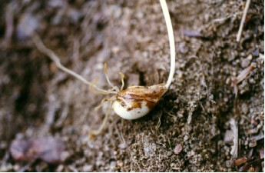

Yellow Trout Lily Bulb

References differ on what the perennial underground system is called. Many call it a bulb because it is in the lily family. Others (Comstock, p. 463) say it is really a corm that is the fleshy swollen base of a stem. While it is bulb like in form, it is not made up of layers like a true bulb. The small “bulb” is covered with a brown scale and has a short tuft of fibrous roots under it. Regardless of which term is used, the plant reproduces underground because rhizomes or runners spread from the main bulb or corm and form small cormels or tiny bulbs. These bury themselves under the surface of the soil and move downward about one inch per year. They send up single leaves but no flowers. (Hull, p. 202) states that they flower for the first time after they get down to about six inches when they send up two leaves. Because they continue to move down, some writers think that they may ultimately get down so deep that they can no longer send stems up through the soil. One grower tried planting the bulbs on rocks at five or six inches to keep the plants from “suicide” but was not sure that worked.
Loretta dug White Trout Lilies from our pasture and planted them in a rocky area near our pond. So far they seem to have continued to bloom.

Seeds

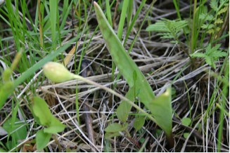

Seed Pod of the White Trout Lily

Light green seed capsules develop during the six to eight week period after flowering. They are oval, somewhat narrowed at the base, and have three distinct divisions. They may become about an inch long. By the time the crescent shaped, about 1/8 inch seeds are ripe, the yellowed leaves of the plant have withered and disappeared and the scape has bent downward so you would have to mark the place where the plants once flowered and look for the seed capsules on the ground. The seeds require a period of cold stratification before germination. It takes at least three or four years for flowering plants to grow from seeds. Most of the plant reproduction seems to be from the spreading underground rhizomes.

Uses
This plant can be used as a ground cover along borders, and in partial shade in rock gardens, shade gardens, and woodland gardens. Remember that it is an ephemeral and will only be visible in spring and very early summer. Be sure to check that your supplier has actually grown the plants and not taken them from the wild because it does take years for flowering plants to grow. Check also the local or state regulations on endangered species.
Edible and medicinal uses: Written sources differ on these uses. Some writers claim that the raw or cooked bulb is quite pleasant and chewy and that the leaves, raw or cooked, could be added to vegetable and salad dishes. Others say that the entire plant is very strongly emetic and should not be used. Still others remind users that eating the leaves will either kill the bulb or reduce its vigor and that it should only be used in an emergency. Small burrowing animals in the woodlands do seem to use the bulbs for food.
American Iroquois women are said to have eaten the leaves to prevent conception.
Some persons made a poultice of the leaves and applied it to swellings and ulcers and used it to help remove splinters.

