Bloodroot Sanguinaria Canadensis

It is easy to understand the source of the common name of this plant for its roots, if broken, exude a bright red juice. The scientific name, Sanguinaria is from a Latin word which means bleeding.
This spring ephemeral grows in rich soils of mixed deciduous forests. The bloodroot is what is known as a stemless plant which means that flowers emerge on a separate stalk or scape from the ground. When it first comes up the leaf is snuggly wrapped around the flower stalk. It blooms from March through May.

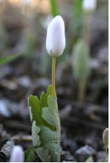

Emerging Bloodroot Plant

The two to four-inch white flower has two sepals and eight or more narrow petals that surround many stamens with yellow anthers and whitish filaments. Bees come for the pollen. The stigma is yellow. Some petals are longer than others.

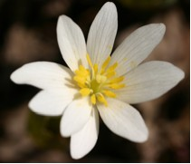

Bloodroot Flower

It opens in bright sun and closes on cloudy days and at night. It blooms only a few days and then the petals drop.

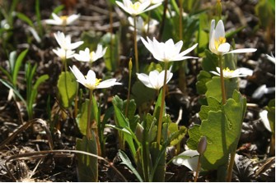

Bloodroots on a Sunny Day

After the flower has bloomed the leaf grows larger. The leaf has seven distinct lobes. Patches of large, notched leaves add beauty to the forest floor.

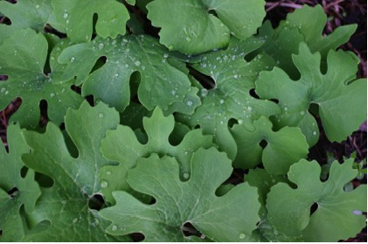

Bloodroot Leaves

The green, two-part seedpod is oblong and pointed at both ends. Inside are many seeds. Ants are attracted to the food rich elaiosomes that surround the seeds and therefore sometimes carry them to their nest. The ants eat the elaiosomes and discard the seeds that then can grow in a new place.

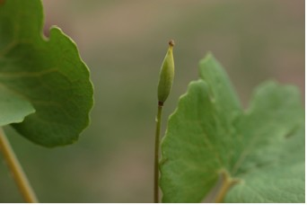

Bloodroot Seed Pod

Plants grow from a large, fleshy, bright red, creeping rhizome. Short roots grow from the rhizome. Native Americans used poisonous, red-orange juice in the roots as a dye for war paint, clothing, and baskets, and as an insect repellent. Without the roots the white flowers would soon wilt.

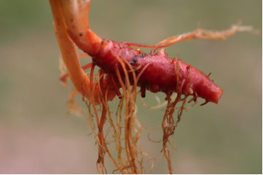

Root of the Bloodroot Plant

Another variety known as S. Canadensis multiplex also exists. It was first found in Michigan. It can now be obtained from some growers. It “resembles a miniature peony, and some hail this as the most beautiful of all wild flowers. It received the 1951 award of merit of the Royal Horticultural Society for new introductions.” (Hull, H., p. 195).

