Bloodroot Sanguinaria Canadensis

PAPAVERACEAE (Poppy Family)

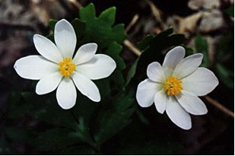

Bloodroot Flowers

What Keeps Us Alive?
The blood of Jesus his Son cleanses us from all sin. 1 John 1:7b (NRSV)

Each of us has red blood that circulates through our veins. It helps keep us alive. Plants have sap instead of blood, but it also helps to keep the plants alive by circulating through the stems, leaves, and flowers. It brings food made in the leaves to other parts of the plant. In one spring flower that sap is as red as blood and gives the plant its name.

The Word of God tells us that Jesus lived and died and gave his blood so that we might live. Christians can live joyfully because of the life-giving blood of Jesus. That life-giving blood helps us “bloom and grow” and share the love of God with others.

Dear God,
Thank you for sending Jesus to give us life now and forever. Help others to know that you love them too. Help us to “bloom and grow” where we are and share with others that our strength and life comes from Jesus. In his name we pray. Amen.

Things to Try
• Find Bloodroot plants and keep a record of when they come up, bloom, form seed pods and disappear.
• Draw or take pictures of the various stages of the Bloodroot plant. Label the pictures.
• Note shapes of different parts of the plant. (Leaves, bud, flower, seed pod)

