Dutchman’s Breeches Dicentra cucullaria

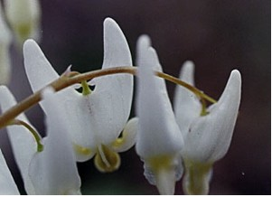

Dutchman’s Breeches

This wildflower blooms in rich woods from April to May. The four to ten Dutchman’s Breeches flowers are attached to a leafless stalk. It is a member of the Poppy Family. The scientific name Dicentra comes from the Greek meaning “two spurred”. Nectar pockets inside the two spurs or petals have tubes leading to them. The proboscis of the early bumblebee is long enough to reach the nectar. Two other petals protect the anthers and stigma and the flower has two small sepals. Cucullaria is from the Latin meaning “hooded”.

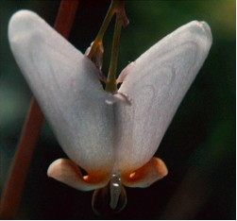

Close-up - Dutchman’s Breeches Flower

The small white flowers resemble pairs of pantaloons or breeches that have been hung up to dry.
In April and May before leaves come out on the trees the Dutchman’s Breeches takes advantage of the abundant sunshine and rises from the ground and blooms. It is a spring ephemeral. By the middle of the summer the plants disappear.
The plants do well on rocky hillsides where they are sheltered from the wind.
The bluish or grayish-green compound leaves are deeply divided and ferny in appearance. The plant grows from four to ten inches high.

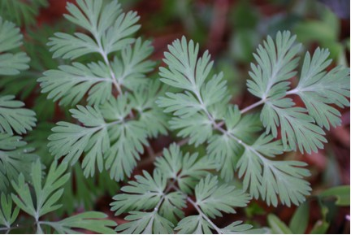

Dutchman’s Breeches Leaves

The divided bulbs are covered with little scales. They and the leaves contain a toxic alkaloid.

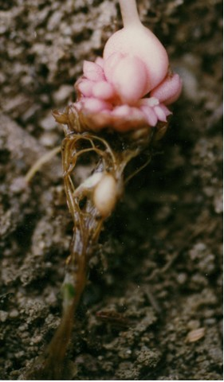

Dutchman’s Breeches Roots

Seeds develop in a long, slender, pointed pod with two parts in it. It contains from ten to twenty seeds.

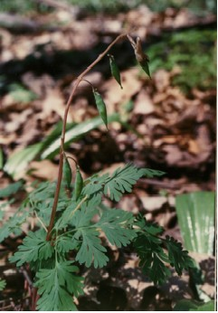

Dutchman’s Breeches Seeds

