Dutchman’s Breeches Dicentra cucullaria

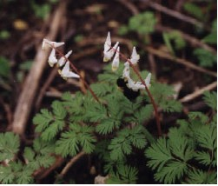

Dutchman’s Breeches and Bumblebee

Because God Loves Us We Need Each Other

Now there are varieties of gifts, but the same Spirit; and there are varieties of services, but the same Lord; and there are varieties of activities, but it is the same God who activates all of them in everyone. To each is given the manifestation of the Spirit for the common good. 1 Corinthians 12:4-7 (NRSV)

God has planned that we need each other and leads us to help one another. In the body of Christ we have variety of gifts and we need each other.
Each of us has special gifts and abilities that fit into God’s larger plan. In the natural world there are many ways in which animals and plants need each other or mutually relate to each other. Early bumblebees come for the nectar of the Dutchman’s Breeches and in the process pollinate the flowers. The bumblebees need the Dutchman’s Breeches and the flowers need the bumblebees.

In early spring this wildflower emerges, blooms, forms seeds, and dies back with no evidence of its presence. It is related to the Bleeding Heart (Dicentra Dielytra spectabilis) that is a favorite of many gardeners.

Dear God,
Lead us to help one another. Help us use the gifts you have given us. In Jesus’ name, Amen.

Things to Think About and Do
• Identify gifts God has given to you. How can you use these gifts to help others?
• Find Dutchman’s Breeches plants. Watch to see if bumblebees come to pollinate them.
• Watch to see what kinds of insects come to pollinate other spring flowers. Try to identify both the insects and the flowers.
• Find other plants and animals that mutually provide for each other’s needs. Write or talk about how you think God planned that other animals and plants should need each other.
• Read about the Dutchman’s Breeches in wildflower books.
• Use a dictionary to find the meaning of the word “breeches”. How do you think the plant got its name?
• Write poems or stories about the Dutchman’s Breeches.

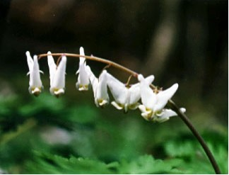

Dutchman’s Breeches Hanging in a Row

Dutchman’s Breeches

Dutchman’s breeches
Hanging in a row,
On a tiny clothesline,
In the woods you grow.
Rain and dew will wash you.
Soil and dirt will go away.
Sun and wind will dry you.
On a sunny day.

Loretta Kuse

