Round-lobed Hepatica Anemone Americana
Sharp-lobed Hepatica Anemone acutiloba

This wildflower received its Latin and common names from the Latin word “epatikos meaning ‘affecting the liver’” (Runkel, S., & Bull, A., p. 7).
The old European “Doctrine of Signatures” maintained that plants that resembled a part of the body were useful in treating disorders of that limb or organ. The color and shape of Hepatica leaves resemble the liver and therefore it was thought that it could treat liver diseases. Hepatica noblis grows in Germany. There it is called Leberblümchen or “Liver Flower”. A German nature guide indicates that its dried leaves are used to cure liver ailments. (Eisenreich, W., p. 252).

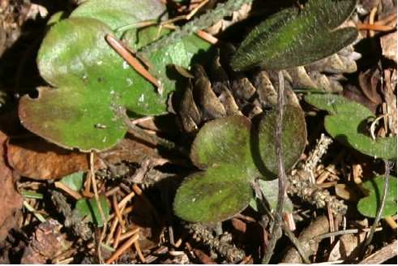

Mature Round-lobed Hepatica Leaves

The Round-lobed Hepatica Anemone Americana has rounded leaves and the Sharp-lobed Hepatica Hepatica acutiloba has sharp leaves and bracts.

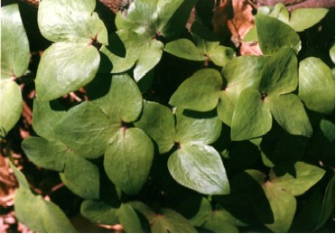

Sharp-lobed Hepatica Leaves Later in Spring

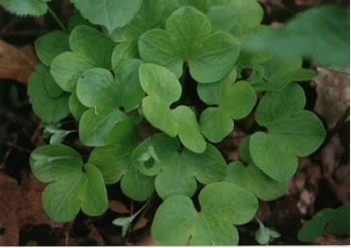

Round-lobed Hepatica Leaves Later in Spring

Hepaticas grow well in rich, moist soil where larger wildflowers will not compete with them. They grow to be about six inches in height. The flower buds on these perennials emerge on hairy stems before the new leaves appear. They bloom from March to June. The petal-like sepals may be shades of violet, pink, or white and are surrounded by three green bracts.

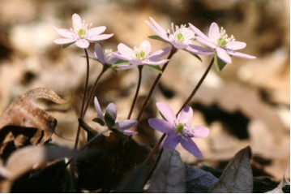

Pink Hepatica Flowers

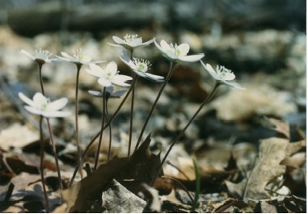

White Hepatica Flowers

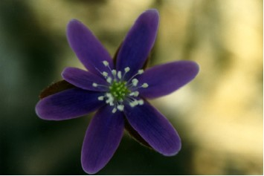

Purple Hepatica Flower

Many stamens with greenish-white anthers surround many pistils that can develop into fruits at the center of the flower. New flowers open on sunny days and close in the dark. As the flowers mature they remain open in varied light.

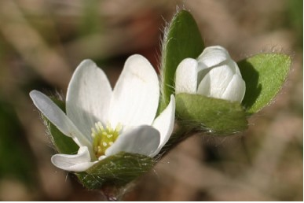

White Hepatica Flowers and Green Bracts

New unfolded, silky and hairy leaves appear soon after the flowers.

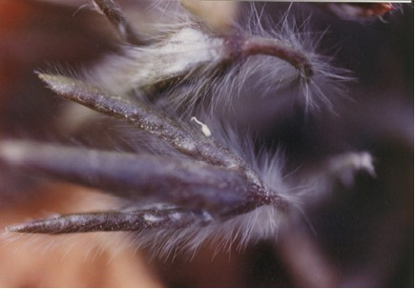

Sharp-lobed Hepatica Leaves in Early Spring

The old leaves are purple and green. As the new leaves open they are rounded for the Round-lobed Hepatica and sharp for the Sharp-lobed Hepatica. As they open they are light green and later they turn dark olive green.
The cylindrical pointed seeds form in a starry cluster.

