Violets, Violas, and Pansies

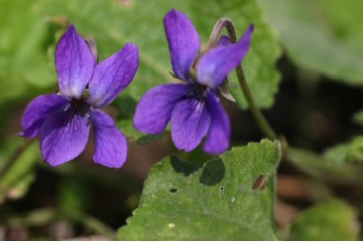

Viola odorata
(Sweet-smelling German Violet)

Nearly everyone has picked violets or recited the rhyme, "Roses are red, violets are blue --- " but did you know that there are over 500 species of plants grown with the botanical name viola in various parts of the world? Violas include both wild and cultivated violets, violas, and pansies.
In Northern Wisconsin most of us are familiar with the common wild blue, yellow, or tiny white violets with heart-shaped leaves. Douglas Fields in his book, The Vascular Plants of Taylor County Wisconsin identifies a dozen members of the violet family growing wild in Taylor County plus a garden escapee, viola tricolor, the familiar Johnny-jump-up.
Gardeners have also cultivated the very fragrant florists' or sweet violet (viola odorata). It was used widely as a cut flower in the past century.
This violet, with deep purple flowers, originated in Europe where it grew abundantly in orchards and along brooks and was celebrated in songs about the coming of spring. Horticulturists developed many new variant strains.
We recently dug sweet violet plants at a location where our grandmother had gardened more than seventy years ago. They had become naturalized as a wild flower. They represented both the old and the new and brought back memories of the songs about springtime that Grandma had learned as a child in Germany.
Since sweet violets are perennial they will reappear in a garden year after year. They make a good ground cover and can be propagated by dividing the plants. Violets can also spread by seed. When the seed capsule ripens and bursts open the seeds are propelled quite a distance from the parent plant.
Some people use the leaves in salads and the purple blossoms in candy or jelly. (Don't eat African Violets. They are not violets and are not edible.)
European folklore identified many medicinal uses of the violet plant. The suggestions resembled a patent medicine ad.
People interested in butterfly gardening know that the larva of the fritillary butterflies eat only violets or other members of the viola family. If you want the beautiful butterflies hovering over your flowers you may need to share a few Johnny-jump-ups or violet plants with the spiny, red, black, and white caterpillars.
Plants change over the centuries as gardeners develop cultivated strains from wild ancestors. Pansies, those friendly-faced members of the viola family, were developed as garden plants in Victorian times. Names such as hearts ease, love-in-idleness, and call-me-to-you suggested that the flower was associated with love. On a visit to northern Europe we heard our hostess call the pansies in her garden “stepmothers”. We later learned that the large petal at the base of the flower represented the rich stepmother, the two side petals her well-dressed daughters, and the two much smaller petals at the top the stepchildren.
Violets and pansies symbolizing friendship and faithfulness have been a favorite of the friendly gardeners in our county ever since the first residents planted their gardens around the tree stumps left from logging days.

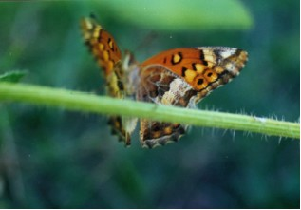

Variegated Fritillary - Euptoieta claudia - Butterflies like these need plants in the viola family as food during the caterpillar stage.

